© 2019 Little Owls Resources

© 2019 Little Owls Resources

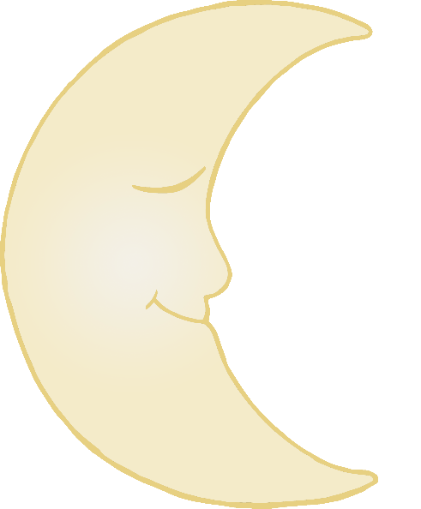

I was relaxing up in the sky because I was feeling a bit sleepy. Suddenly a cow jumped over me! A COW! I couldn’t believe it!

© 2019 Little Owls Resources

© 2019 Little Owls Resources

I was in the mood for some music so I started to play my fiddle. The cow enjoyed it so much that she jumped over the moon!

© 2019 Little Owls Resources

© 2019 Little Owls Resources

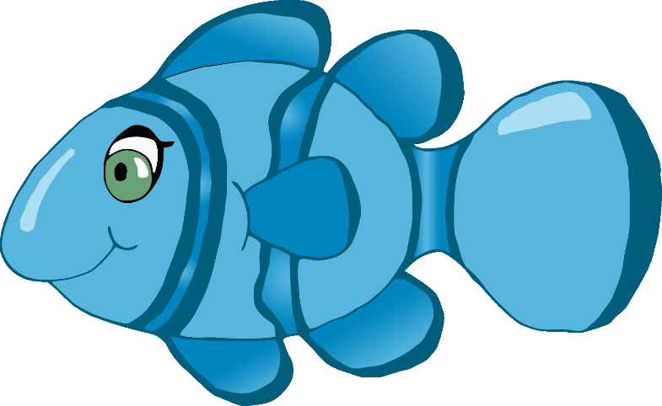

I was having a little swim when someone with a net caught me! I managed to escape by biting them on the finger!

© 2019 Little Owls Resources

© 2019 Little Owls Resources

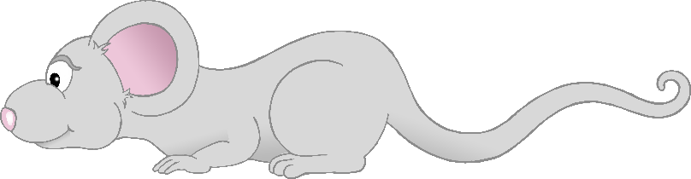

I decided to run up to the top of the big clock. It gave me a fright when the clock struck one! It was REALLY loud! I ran back down as fast as I could!

© 2019 Little Owls Resources

© 2019 Little Owls Resources

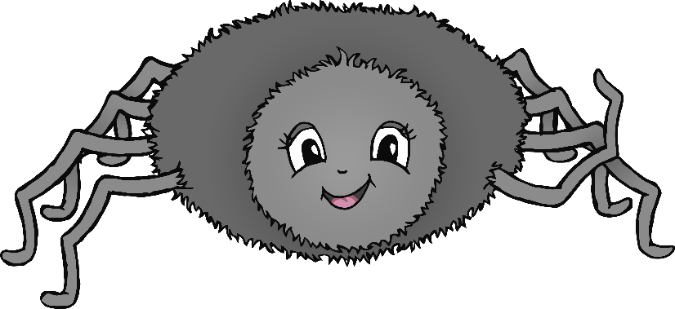

I thought it’d be fun to climb up the waterspout, but just then it started to rain! The water washed me out of the pipe!

© 2019 Little Owls Resources

© 2019 Little Owls Resources

I was quite surprised to see the cat playing the fiddle. I started to dance and then I jumped up and OVER the moon!

© 2019 Little Owls Resources

© 2019 Little Owls Resources

Today I saw my friend the cat playing a fiddle and then the cow jumped OVER the moon! It was SO funny. I couldn’t stop laughing!



I usually stay high above the earth. You will probably see me twinkling at night. Some people even say that I look like a diamond.

© 2019 Little Owls Resources

© 2019 Little Owls Resources