People Who Help Us

Nurse

The pages of this pack give some general information about the role of a nurse and some fun and engaging activities to foster and develop children’s interest in this role in society.

This pack includes:

* Information Posters
* Information Posters (Colouring)
* Drawing/Writing Sheets
* Draw items Sheet
* Draw items Sheet (Colouring)
* Item Poster
* Item Poster (Colouring)
* Multimats for Art & Craft/Loose Parts/Playdough
* 5x 2-Piece individual items puzzles
* 1x 4-Piece all items puzzle

© 2021 Little Owls Resources

© 2021 Little Owls Resources

Nurse

I’m a **nurse.**

I care for people who are sick or injured in a hospital or in the community.

I work closely with doctors to help people get better as quickly as possible.

I also give important advice about staying healthy!

I use a thermometer to check a patient’s temperature.

Nurse

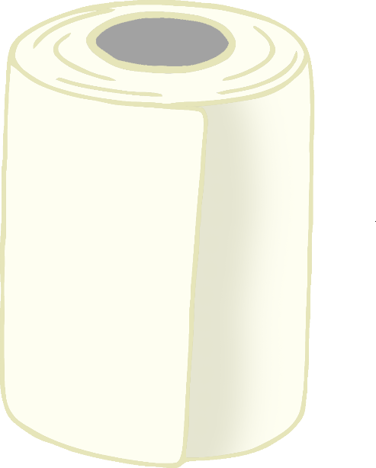

I use an upside-down fob watch so I can see the time without needing a watch on my wrist.

If someone is injured, I use a bandage to dress their wound.

© 2021 Little Owls Resources

I use a syringe to give important medicines.

© 2021 Little Owls Resources

**Nurse**

**I’m a nurse.**

**I care for people who are sick or injured in a hospital or in the community.**

**I work closely with doctors to help people get better as quickly as possible.**

**I also give important advice about staying healthy!**

**I use a thermometer to check a patient’s temperature.**

**Nurse**

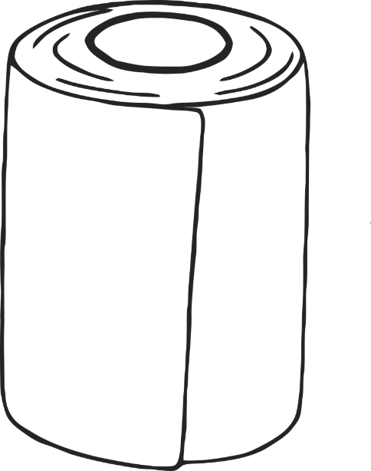

**I use an upside-down fob watch so I can see the time without needing a watch on my wrist.**

**If someone is injured, I use a bandage to dress their wound.**

**I use a syringe to give important medicines.**

© 2021 Little Owls Resources

© 2021 Little Owls Resources

Draw a Nurse!

© 2021 Little Owls Resources

Draw and write about a Nurse!

_________________________________________________________

© 2021 Little Owls Resources

Draw and write about a Nurse!

________________________________________________________________________________________________________________________________________________

**Can you draw the items a nurse needs?**

© 2021 Little Owls Resources

**Can you draw the items a nurse needs?**

© 2021 Little Owls Resources

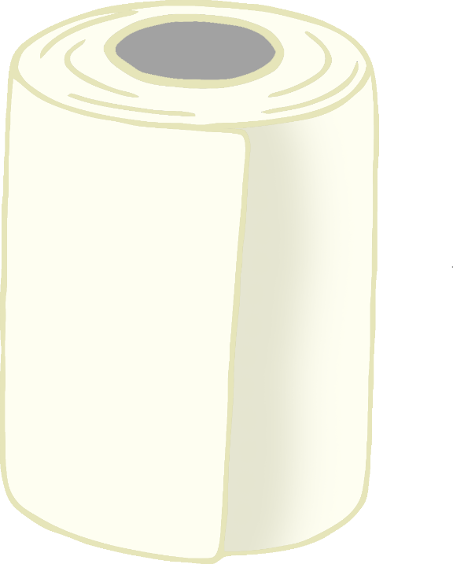

Nurse

© 2021 Little Owls Resources

Syringe

Thermometer

Fob Watch

Bandage

**Nurse**

© 2021 Little Owls Resources

**Fob Watch**

**Thermometer**

**Bandage**

**Syringe**

Nurse Multimat - Thermometer

© 2021 Little Owls Resources

Nurse Multimat – Fob Watch

© 2021 Little Owls Resources

Nurse Multimat – Syringe

© 2021 Little Owls Resources

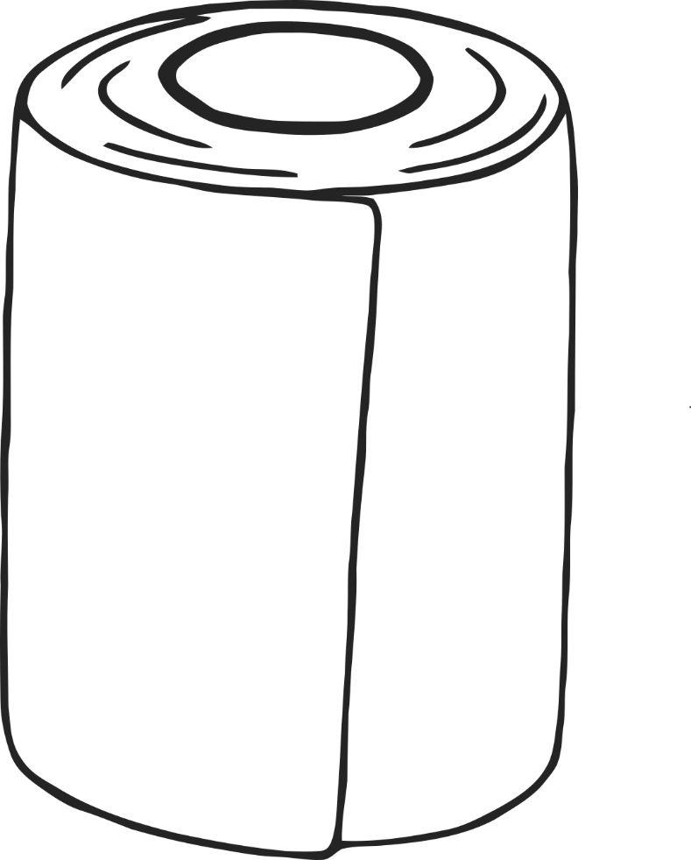

Nurse Multimat – Bandage

© 2021 Little Owls Resources

© 2021 Little Owls Resources

© 2021 Little Owls Resources

© 2021 Little Owls Resources

© 2021 Little Owls Resources

© 2021 Little Owls Resources

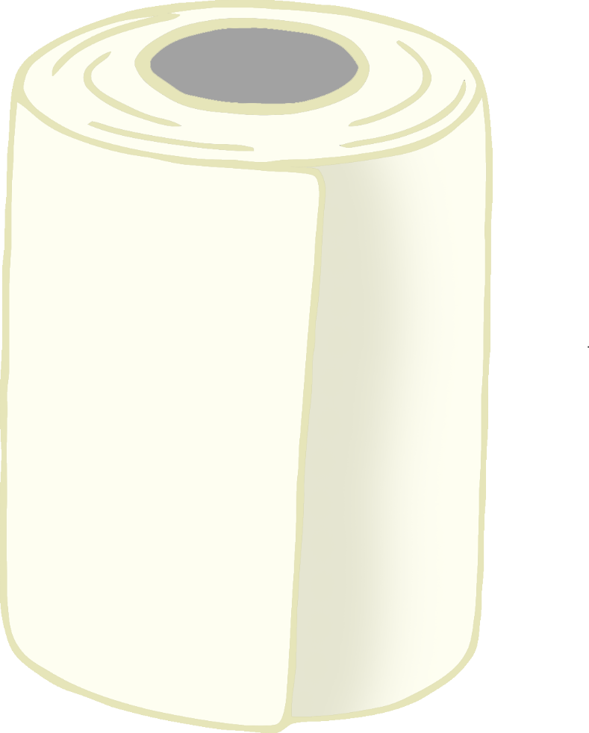

**Nurse**

© 2021 Little Owls Resources

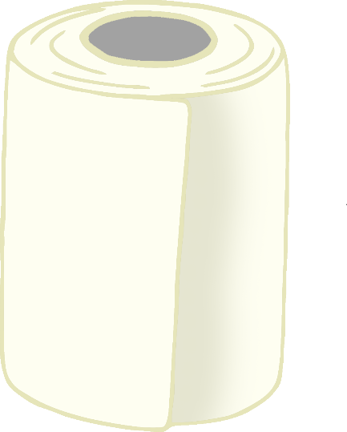

Thermometer

Bandage

Fob Watch

Syringe