0

0 0 0

0 0 0 0 0

0 0

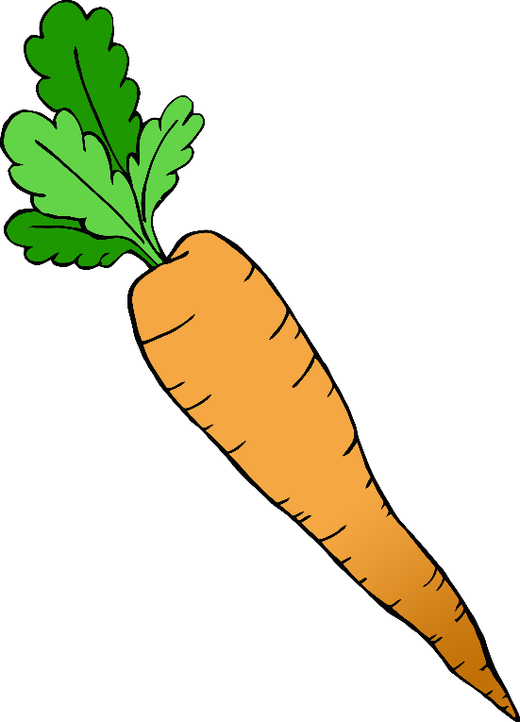

1

1 1

1 1 1

1 1 1 1 1

2

2 2 2 2 2

2 2 2

2 2

3

3 3

3 3 3

3 3 3 3 3



4



1

1

4 4

4 4 4

4 4 4 4 4

5 5 5 5 5

5 5 5

5 5

5

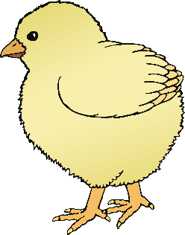

6

6 6 6 6 6

6 6 6

6 6

7

7 7 7 7 7

7 7 7

7 7

8

8 8 8 8 8

8 8 8

8 8

9

9 9

9 9 9

9 9 9 9 9

10

10 10 10 10 10

10 10

10 10 10



1

1

5 5 5 5 5

5 5 5

5 5

5