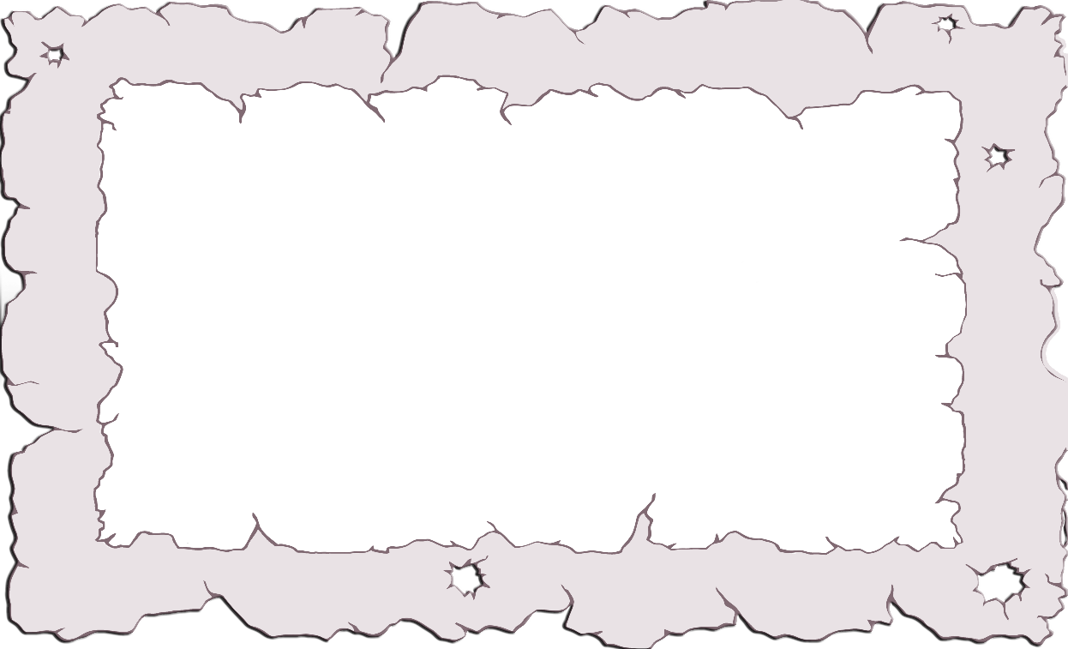

These magic words must have been left behind by a forgetful witch!

I can’t read them at all....Can you help?

**Mystery Magic Words!**



© 2019 Little Owls Resources

© 2019 Little Owls Resources

hib

lif

© 2019 Little Owls Resources

© 2019 Little Owls Resources

© 2019 Little Owls Resources

dag

vug

jav

© 2019 Little Owls Resources

© 2019 Little Owls Resources



© 2019 Little Owls Resources

© 2019 Little Owls Resources

© 2019 Little Owls Resources

pij

hes

jiv



© 2019 Little Owls Resources

© 2019 Little Owls Resources

© 2019 Little Owls Resources

gef

som

kig



© 2019 Little Owls Resources

© 2019 Little Owls Resources

© 2019 Little Owls Resources

gol

suv

kib



© 2019 Little Owls Resources

© 2019 Little Owls Resources

© 2019 Little Owls Resources

tog

ruv

jun



© 2019 Little Owls Resources

© 2019 Little Owls Resources

© 2019 Little Owls Resources

yut

doj

lim



nes



© 2019 Little Owls Resources

© 2019 Little Owls Resources

© 2019 Little Owls Resources

gek

muf



© 2019 Little Owls Resources

zob

dak



© 2019 Little Owls Resources

© 2019 Little Owls Resources

zib



© 2019 Little Owls Resources

© 2019 Little Owls Resources

© 2019 Little Owls Resources

vix

wis

rab



© 2019 Little Owls Resources

© 2019 Little Owls Resources

© 2019 Little Owls Resources

puk

teg

heb





© 2019 Little Owls Resources

© 2019 Little Owls Resources

© 2019 Little Owls Resources

kib

kuv

zav