**New Year**

Circle game

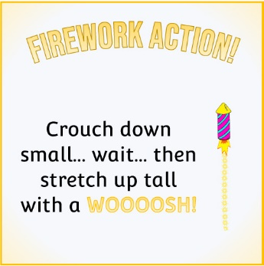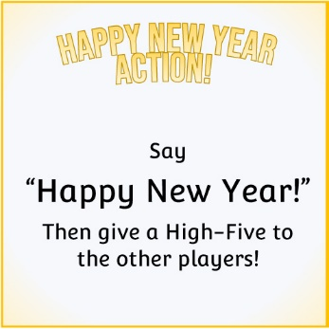

Small group of children to sit in a circle with the cards spread out on the floor face-down. Children take turns to flip over a card and follow the instructions!

*N.B. For the counting fireworks cards, the adult in charge can choose which numbers are appropriate for the children involved.*

© 2019 Little Owls Resources

**Firework Action!**

**Happy New Year!**

Crouch down small… wait… then stretch up tall with a **WOOOOSH!**

© 2019 Little Owls Resources

**Firework Action!**

**Happy New Year!**

Stretch your arms up and then out wide. Then flick your fingers like popping fireworks…

**Pop! Pop! Pop! Pop!**

© 2019 Little Owls Resources

**HaPPY NEW YEAR**

**Action!**

**Happy New Year!**

Say

“Happy New Year!”

Then give a High-Five to the other players!

© 2019 Little Owls Resources

**Happy New Year!**

**HaPPY NEW YEAR**

**Action!**

Say

“Happy New Year!”

Then give a High-Five to the other players!

Everyone crosses their arms in front of them and then holds hands in a circle.

Say

“Happy New Year!”

© 2019 Little Owls Resources

**Question time!**

**Happy New Year!**

What is your favourite food?

© 2019 Little Owls Resources

**Question Time!**

What is your favourite drink?

**Happy New Year!**

© 2019 Little Owls Resources

**Next year…**

Finish this sentence…

“Next year I want to…”

**Happy New Year!**

© 2019 Little Owls Resources

Finish this sentence…

“Next year I hope…”

**Next year…**

**Happy New Year!**

© 2019 Little Owls Resources

**Countdown Claps!**

5 4 3 2 1

**Happy New Year!**

© 2019 Little Owls Resources

**Countdown Claps!**

10 9 8 7 6 5 4 3 2 1

**Happy New Year!**

© 2019 Little Owls Resources

**How Many Fireworks?**

**Happy New Year!**

© 2019 Little Owls Resources

**How Many Fireworks?**

**Happy New Year!**

© 2019 Little Owls Resources

**How Many Fireworks?**

**Happy New Year!**

© 2019 Little Owls Resources

**How Many Fireworks?**

**Happy New Year!**

© 2019 Little Owls Resources

**How Many Fireworks?**

**Happy New Year!**



© 2019 Little Owls Resources

**How Many Fireworks?**

**Happy New Year!**

