My pet spider can…

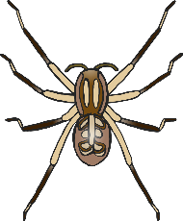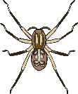

© 2023 Little Owls Resources

© 2023 Little Owls Resources

________­­­­­­­­­­­­­­­­­­­______________________

______________________________

______________________________

______________________________

­______________________________

______________________________

­______________________________

______________________________

My pet spider can…



© 2023 Little Owls Resources

**________­­­­­­­­­­­­­­­­­­­______________________**

**______________________________**

**______________________________**

**______________________________**

**­______________________________**

**______________________________**

**­______________________________**

My pet spider can…



© 2023 Little Owls Resources

**______________________________________________________**

­**______________________________________________________**

**______________________________________________________**

**______________________________________________________**

**______________________________________________________**

**______________________________________________________**

**______________________________________________________**

My pet spider can…

