Transitions

This booklet is intended for children to record information about themselves to be passed to a new teacher. There is space for drawing, writing or both!

© 2022 Little Owls Resources

‘This is me!’ booklet

© 2022 Little Owls Resources

my name

This is

© 2022 Little Owls Resources

**This is me!**

**booklet**

**My**

© 2022 Little Owls Resources

This is a

picture

of me!

© 2022 Little Owls Resources

This is my family!

This is where I live!

© 2022 Little Owls Resources

© 2022 Little Owls Resources

favourite

colour!

My

© 2022 Little Owls Resources

This is my favourite food!

This is my favourite TV show!

© 2022 Little Owls Resources

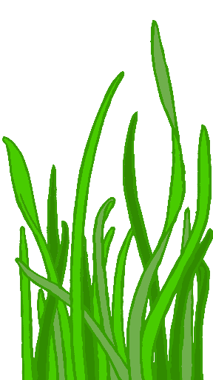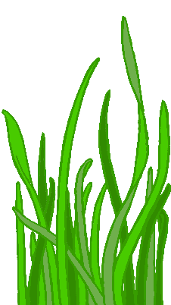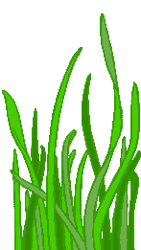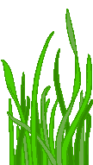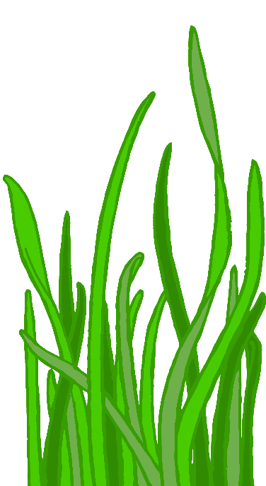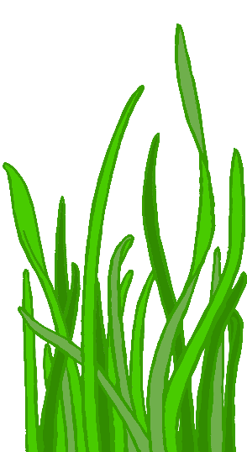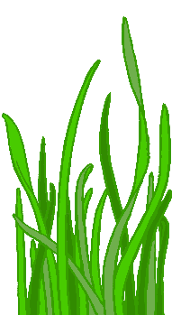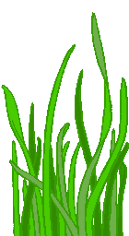

© 2022 Little Owls Resources

This is my favourite animal!

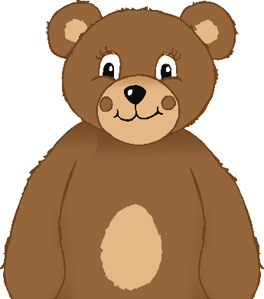

This is my favourite toy!

© 2022 Little Owls Resources