My Teddy

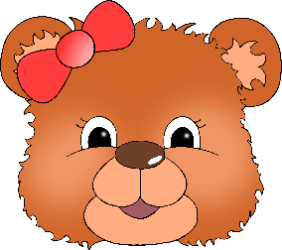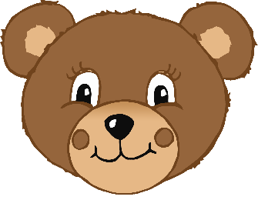

© 2021 Little Owls Resources

________________________________________________________________________________________________________

My Teddy



____________________________

© 2021 Little Owls Resources

© 2020 Little Owls Resources

My Teddy



© 2021 Little Owls Resources