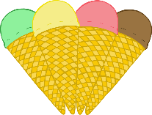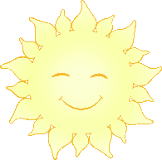

**My Summer Senses Poem**



© 2021 Little Owls Resources

I can feel…

I can smell…

I can hear…

I can see…

**My Summer Senses Poem**



I can see…

I can taste…

© 2021 Little Owls Resources

I can feel…

I can smell…

I can hear…