**Summer Senses**

**My**

**Booklet**

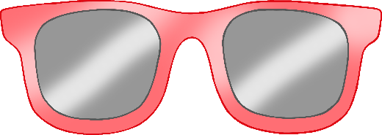

© 2021 Little Owls Resources

© 2021 Little Owls Resources

In **Summer** I can smell…

© 2021 Little Owls Resources

In **Summer** I can feel…

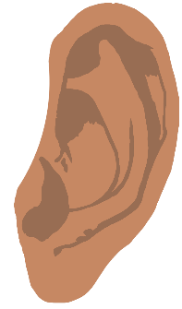

© 2021 Little Owls Resources

In **Summer** I can hear…

© 2021 Little Owls Resources

In **Summer** I can see…

© 2021 Little Owls Resources

In **Summer** I can taste…