Checklists

My Summer Holiday

These checklists are to give children and adults ideas for summer activities. There are two sheets with ideas to tick when they are completed and then one sheet of blank squares for additional ideas!

© 2022 Little Owls Resources

© 2022 Little Owls Resources

Visit the zoo

Go swimming

Have a picnic

Read books

Visit the park

Explore minibeasts

Cooking

Tell jokes

Exercise

My Summer Holiday



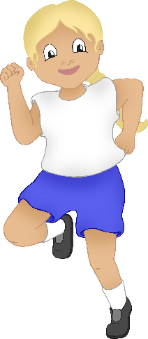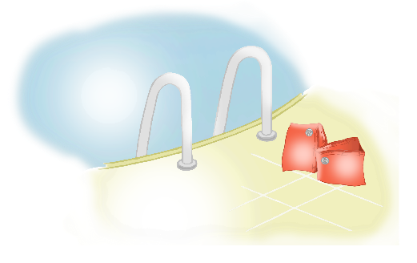

© 2022 Little Owls Resources

Water play

Sand play

Mud kitchen

Bird watching

Play sport

Visit the beach

Make music

Drawing and painting

Investigate a rockpool

My Summer Holiday



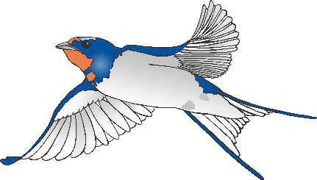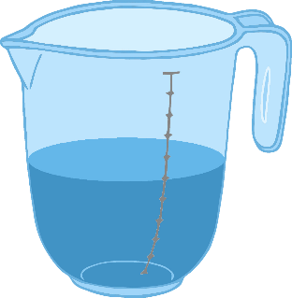

My Summer Holiday



© 2022 Little Owls Resources