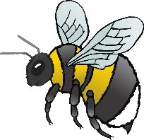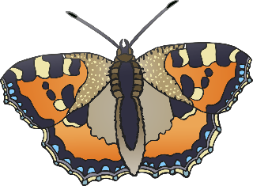

© 2021 Little Owls Resources

**Spring Senses**

**My**

**Booklet**

© 2021 Little Owls Resources

In **Spring** I can smell…

© 2021 Little Owls Resources

In **Spring** I can feel…

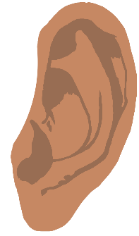

© 2021 Little Owls Resources

In **Spring** I can hear…

© 2021 Little Owls Resources

In **Spring** I can see…

© 2021 Little Owls Resources

In **Spring** I can taste…