_______________________________________________________________________________________________

© 2023 Little Owls Resources

My mummy likes…

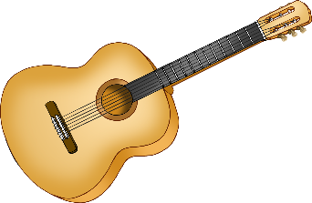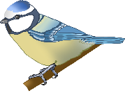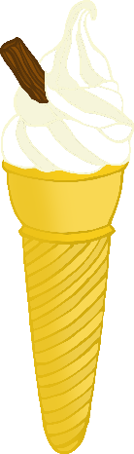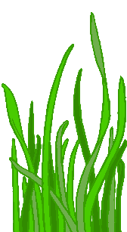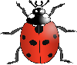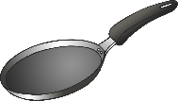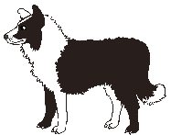

_______________________________________

© 2023 Little Owls Resources

My mummy likes…



© 2023 Little Owls Resources

My mummy likes…



_______________________________________________________________________________________________

© 2023 Little Owls Resources



_______________________________________

© 2023 Little Owls Resources



© 2023 Little Owls Resources

Little Owls Resources

