**My Gardening**

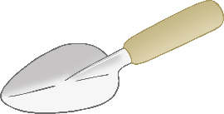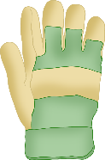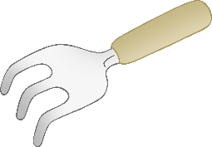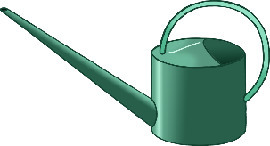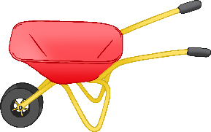

© 2023 Little Owls Resources

**My Gardening**



© 2023 Little Owls Resources

________­­­­­­­­­­­­­­­­­­­______________________

______________________________

______________________________

______________________________

­______________________________

______________________________

­______________________________

______________________________

**My Gardening**



© 2023 Little Owls Resources

**________­­­­­­­­­­­­­­­­­­­______________________**

**______________________________**

**______________________________**

**______________________________**

**­______________________________**

**______________________________**

**­______________________________**

**My Gardening**



**________________________________________________________________________________________________________________________________________________________________________________________________________________________________________________________________________________________________________________________________________________________________________________**

© 2023 Little Owls Resources