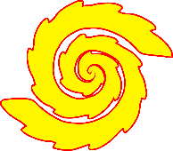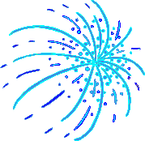

My Fireworks Senses Poem

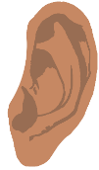

© 2022 Little Owls Resources

I can feel…

I can smell…

I can hear…

I can see…



My Fireworks Senses Poem



I can see…

I can taste…

© 2022 Little Owls Resources

I can feel…

I can smell…

I can hear…