Fireworks Senses

Booklet

My



© 2020 Little Owls Resources

© 2020 Little Owls Resources

On **firework night** I can smell…

© 2020 Little Owls Resources

On **firework night** I can feel…



© 2020 Little Owls Resources

On **firework night** I can hear…

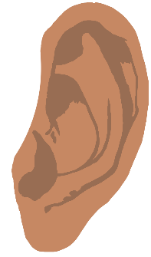

© 2020 Little Owls Resources

On **firework night** I can see…

© 2020 Little Owls Resources

On **firework night** I can taste…