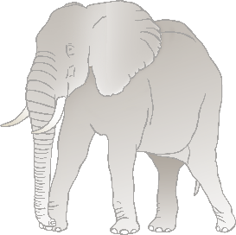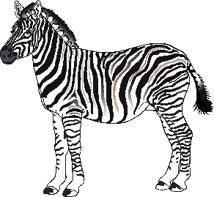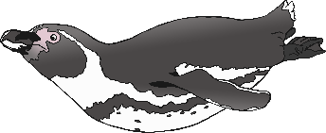

**My Favourite Zoo Animal**

_________________________________________________________________________________________

__________________________________________



**My Favourite Zoo Animal**



My Favourite Zoo Animal

_________________________________________________________________________________________



**My Favorite Zoo Animal**

__________________________________________



**My Favorite Zoo Animal**



**My Favorite Zoo Animal**