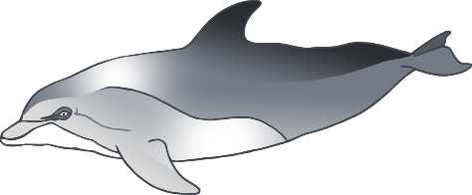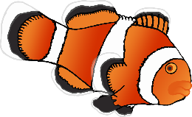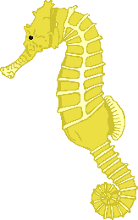

My Favourite Sea Animal

© 2020 Little Owls Resources

________________________________________________________________________________________________________



____________________________

My Favourite Sea Animal

© 2020 Little Owls Resources

© 2020 Little Owls Resources



My Favourite Sea Animal

© 2020 Little Owls Resources



My Favorite Sea Animal

________________________________________________________________________________________________________

© 2020 Little Owls Resources



My Favorite Sea Animal

____________________________

© 2020 Little Owls Resources



My Favorite Sea Animal

© 2020 Little Owls Resources