**My Favourite Garden Bird**

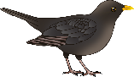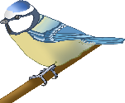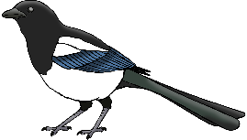

© 2020 Little Owls Resources

________________________________________________________________________________________________________

**My Favourite Garden Bird**



____________________________

© 2020 Little Owls Resources

© 2020 Little Owls Resources



**My Favourite Garden Bird**

© 2020 Little Owls Resources



**My Favorite Garden Bird**

________________________________________________________________________________________________________

© 2020 Little Owls Resources



**My Favorite Garden Bird**

____________________________

© 2020 Little Owls Resources



**My Favorite Garden Bird**

© 2020 Little Owls Resources