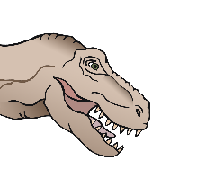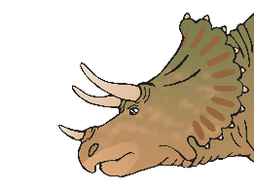

MY FAVOURITE DINOSAUR

_________________________________________________________________________________________

© 2019 Little Owls Resources

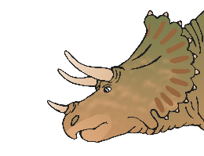

MY FAVOURITE DINOSAUR

__________________________________________

© 2019 Little Owls Resources



MY FAVOURITE DINOSAUR

© 2019 Little Owls Resources



MY FAVORITE DINOSAUR

_________________________________________________________________________________________

© 2019 Little Owls Resources



MY FAVORITE DINOSAUR

__________________________________________

© 2019 Little Owls Resources



MY FAVORITE DINOSAUR

© 2019 Little Owls Resources