Diwali Senses

Booklet

My

© 2022 Little Owls Resources

© 2022 Little Owls Resources

During Diwali I can smell…

© 2022 Little Owls Resources

During Diwali I can feel…

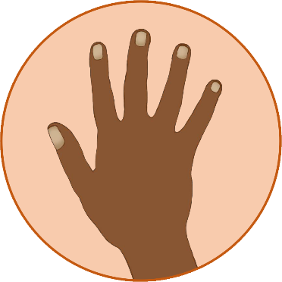

© 2022 Little Owls Resources

During Diwali I can hear…

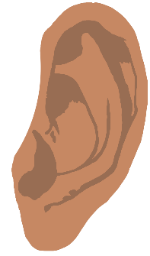

© 2022 Little Owls Resources

During Diwali I can see…

© 2022 Little Owls Resources

During Diwali I can taste…