Draw and Write

**My Diwali Celebrations**

These sheets are intended to encourage children to record experiences of their Diwali celebrations. They are differentiated by amounts of expected writing.

© 2022 Little Owls Resources

**My Diwali Celebrations**

Draw and Write

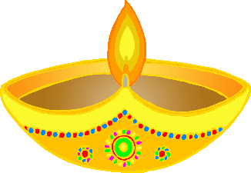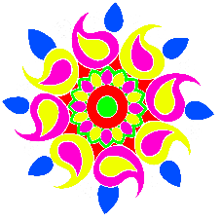

© 2022 Little Owls Resources

**My Diwali Celebrations**

Draw and Write



© 2022 Little Owls Resources

________­­­­­­­­­­­­­­­­­­­______________________

______________________________

______________________________

______________________________

­______________________________

______________________________

­______________________________

______________________________

**My Diwali Celebrations**

Draw and Write



© 2022 Little Owls Resources

**________­­­­­­­­­­­­­­­­­­­______________________**

**______________________________**

**______________________________**

**______________________________**

**­______________________________**

**______________________________**

**­______________________________**

**My Diwali Celebrations**

Draw and Write



© 2022 Little Owls Resources

**______________________________________________________**

­**______________________________________________________**

**______________________________________________________**

**______________________________________________________**

**______________________________________________________**

**______________________________________________________**

**______________________________________________________**