_______________________________________________________________________________________________

© 2022 Little Owls Resources

My daddy likes…

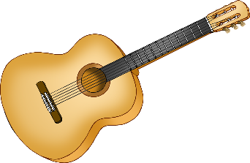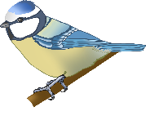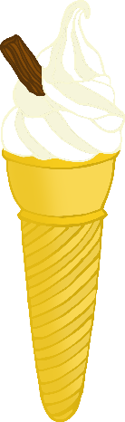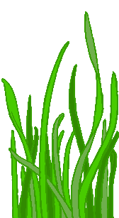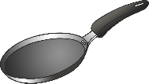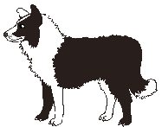

_______________________________________

© 2022 Little Owls Resources

My daddy likes…



© 2022 Little Owls Resources

My daddy likes…



_______________________________________________________________________________________________

© 2022 Little Owls Resources



_______________________________________

© 2022 Little Owls Resources



© 2022 Little Owls Resources

