**Booklet**

**Autumn Senses**

**My**

© 2020 Little Owls Resources

© 2020 Little Owls Resources

In **Autumn** I can smell…

© 2020 Little Owls Resources

In **Autumn** I can feel…

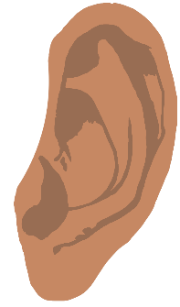

© 2020 Little Owls Resources

In **Autumn** I can hear…

© 2020 Little Owls Resources

In **Autumn** I can see…

© 2020 Little Owls Resources

In **Autumn** I can taste…