Music

Wall

© 2020 Little Owls Resources

© 2020 Little Owls Resources

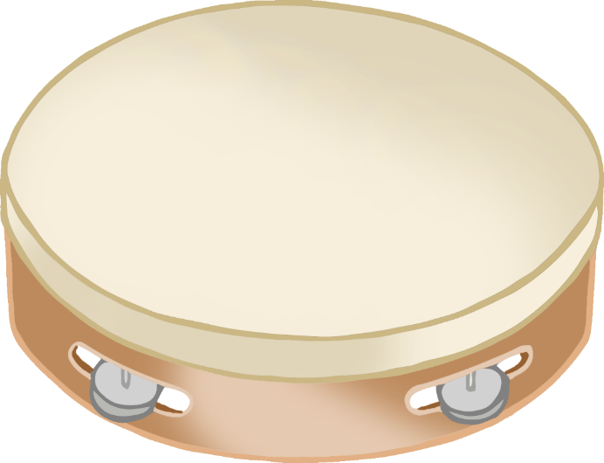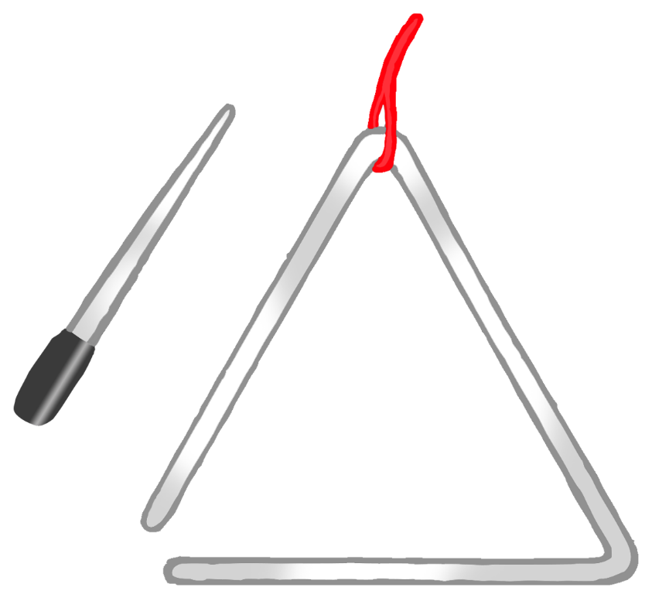

Music Area

