Collect spoons of mud.

© 2021 Little Owls Resources

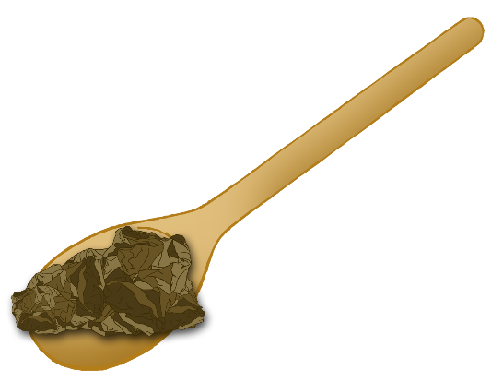

**Mud Kitchen Ingredient Challenge!**

Collect sticks.

© 2021 Little Owls Resources



**Mud Kitchen Ingredient Challenge!**

© 2021 Little Owls Resources



**Mud Kitchen Ingredient Challenge!**

Collect stones.

Collect leaves.

© 2021 Little Owls Resources



**Mud Kitchen Ingredient Challenge!**

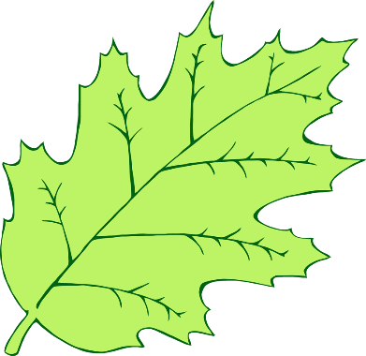

© 2021 Little Owls Resources

**Mud Kitchen Ingredient Challenge!**

Collect cups of water.

© 2021 Little Owls Resources



**Mud Kitchen Ingredient Challenge!**