© 2021 Little Owls Resources

This can be used as a group game or as an individual task. A die is rolled to find a number and then the children have to perform the action.

The colouring version can add an extra activity after each roll.

**All About Me**

Move Yourself! – Dice game

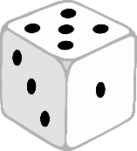

© 2021 Little Owls Resources

**1**

**3**

**4**

**5**

**6**

Blink your eyes.

Stamp your feet.

Pat your head.

Rub your tummy.

Clap your hands.

Wiggle your nose.

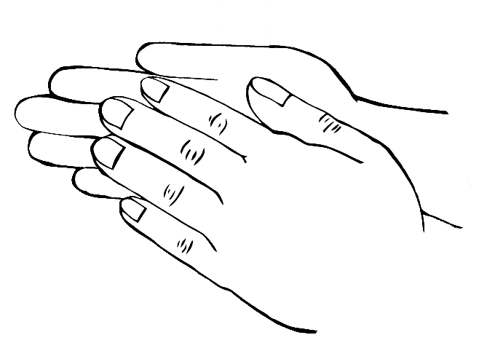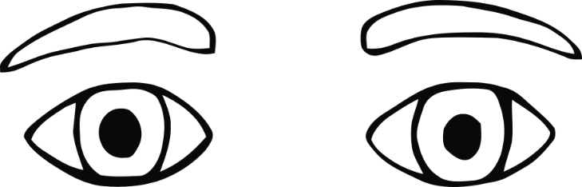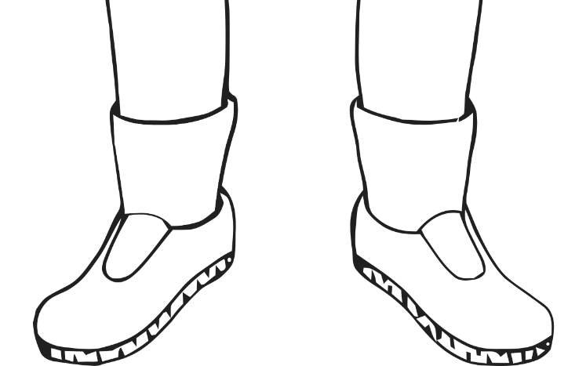

**2**

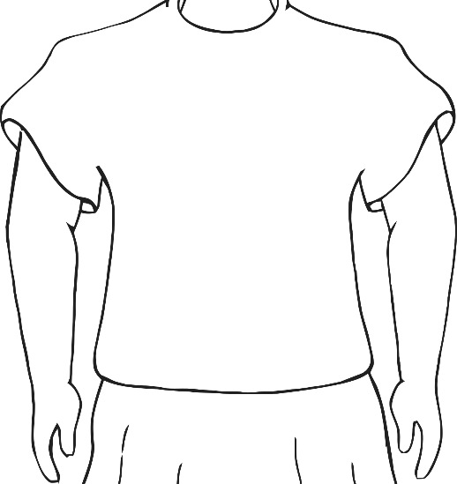

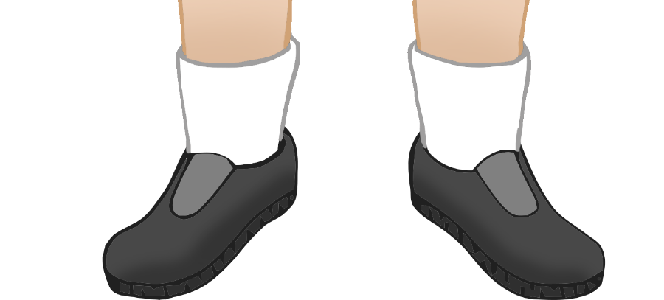

© 2021 Little Owls Resources

1

3

4

5

6

Blink your eyes.

Stamp your feet.

Pat your head.

Rub your tummy.

Clap your hands.

Wiggle your nose.

2