©2024 Little Owls Resources

Love

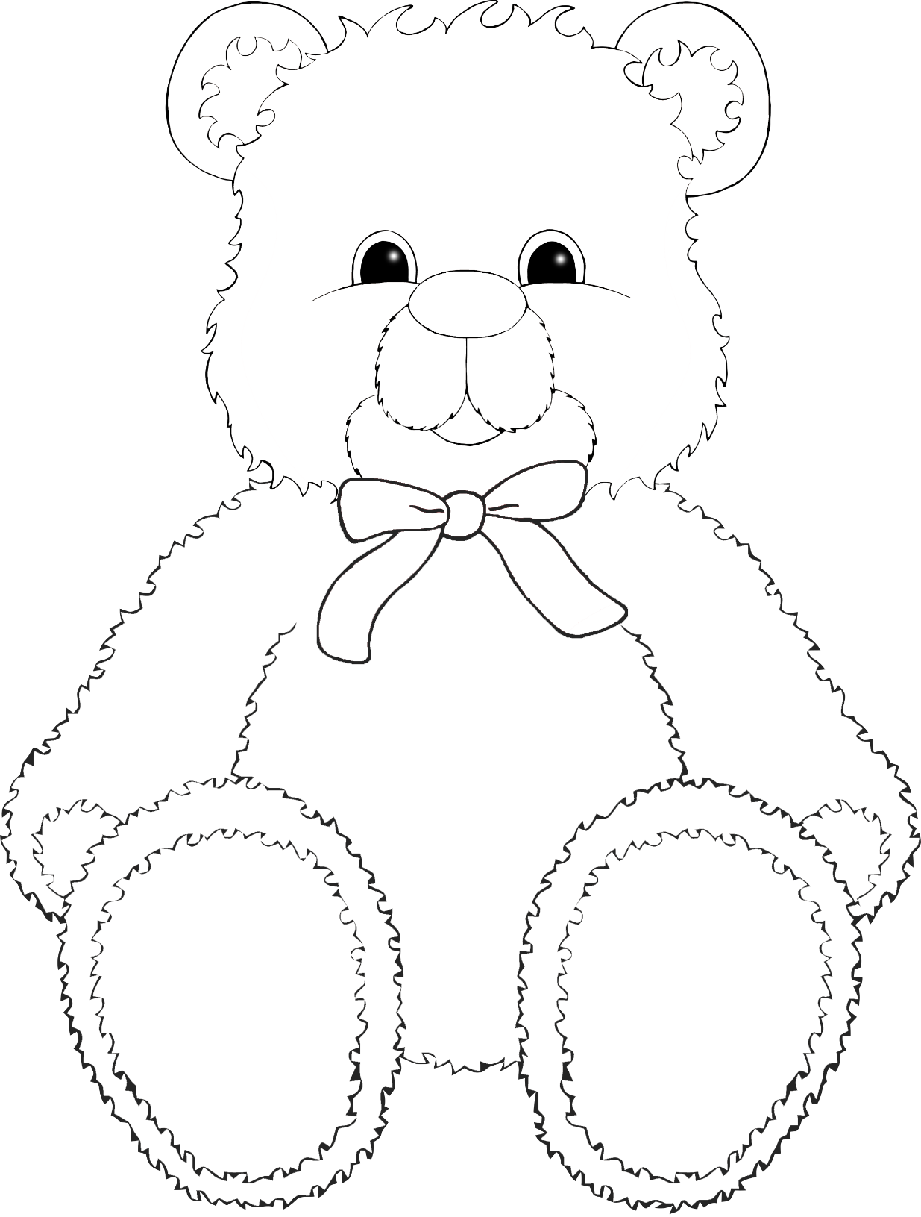

©2024 Little Owls Resources



©2024 Little Owls Resources

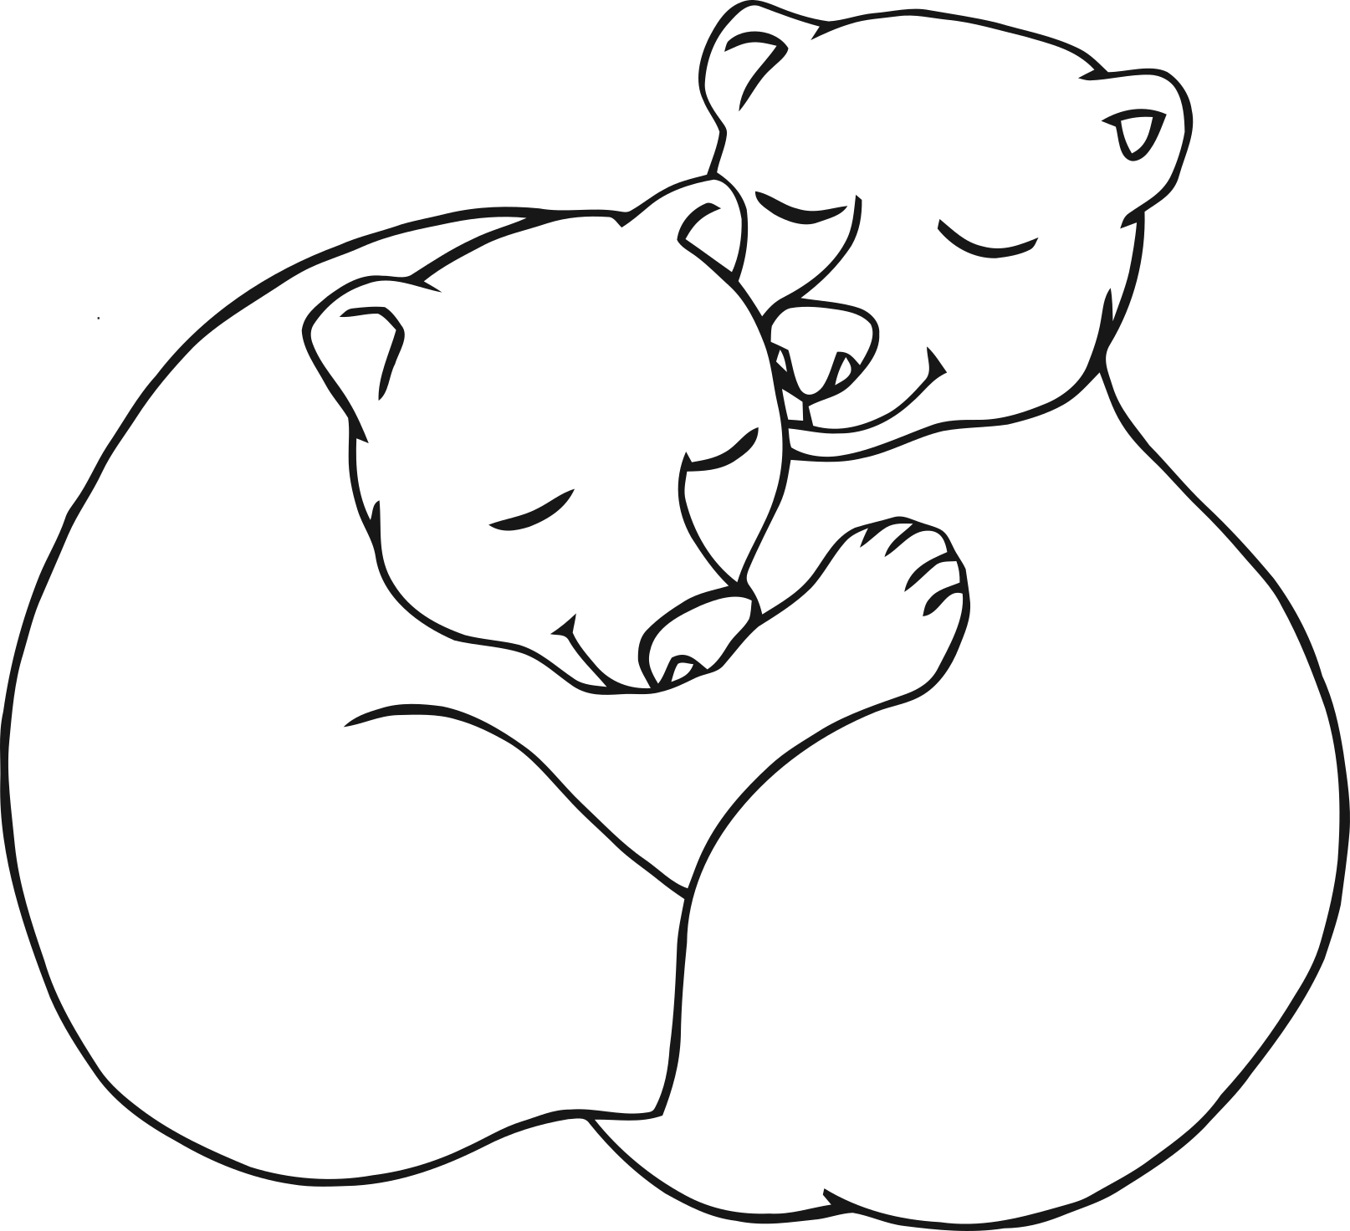

I love you Mummy!

©2024 Little Owls Resources



I love you!

©2024 Little Owls Resources

You’re the best!



Mummy!

©2024 Little Owls Resources

You’re the best!



©2024 Little Owls Resources

Mummy!



©2024 Little Owls Resources



©2024 Little Owls Resources

I Love my Mummy!

©2024 Little Owls Resources

I Love You!

©2024 Little Owls Resources

Happy Mother’s Day!

©2024 Little Owls Resources

Thank you!