Mother’s Day A4 templates

©2022 Little Owls Resources

These templates have detailed outlines to be used as a starting point for an art activity.

The outlines can be coloured, painted, or collaged to create an individual poster design.

They could also be stuck to a folded piece of A3 card to make a large Mother’s Day card!

Best mummy in the world!

Best mummy in the world!

Dear Mummy

I love you!

©2022 Little Owls Resources

Happy

Mother’s Day!

©2022 Little Owls Resources

Mummy!

©2022 Little Owls Resources

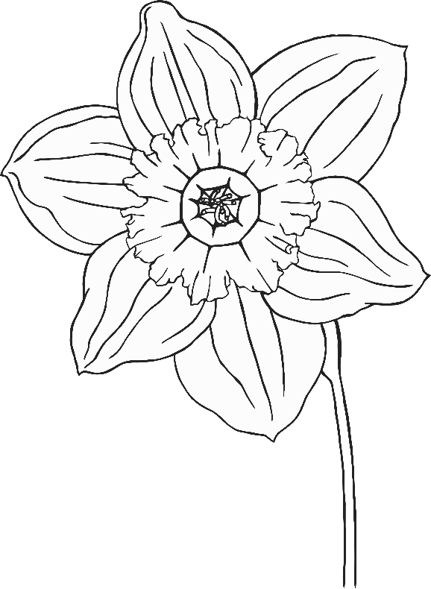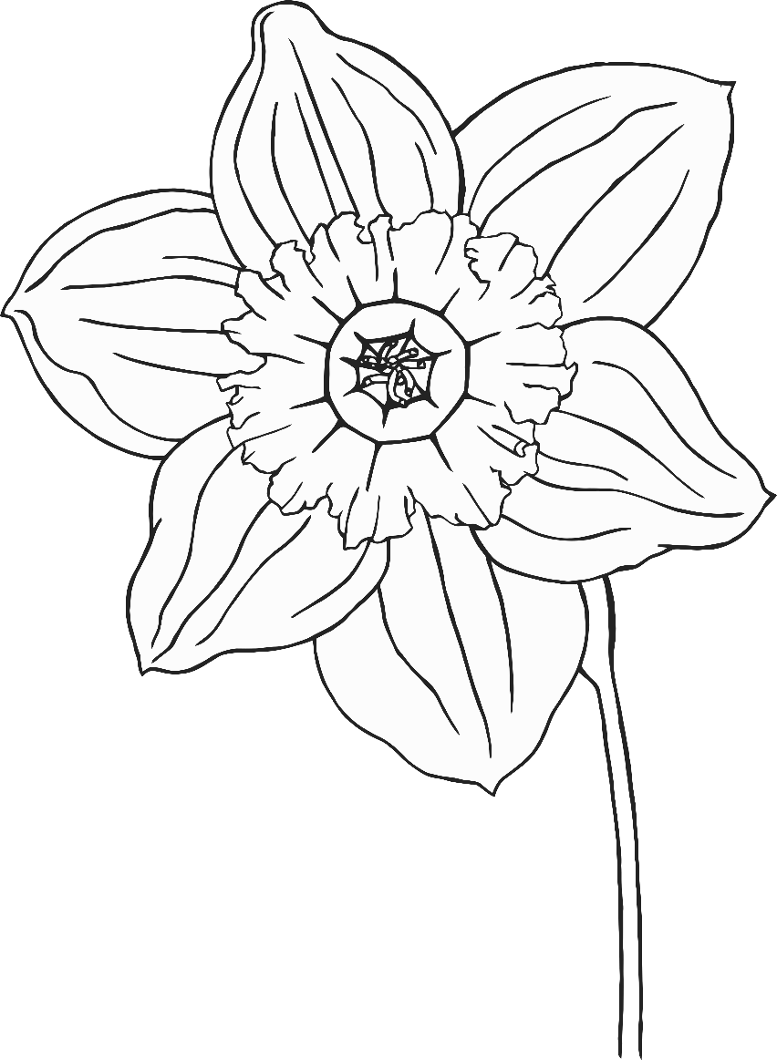

Mother’s Day

Happy

©2022 Little Owls Resources

**Love you**

**Mummy!**

©2022 Little Owls Resources

Best mummy in the world!

©2022 Little Owls Resources

**I love you mummy!**

©2022 Little Owls Resources

…You’re the best!

Mummy…

©2022 Little Owls Resources

©2022 Little Owls Resources

**you mummy!**

©2022 Little Owls Resources

**My mummy!!**

**Happy Mother’s Day!**

©2022 Little Owls Resources

**Happy Mother’s Day!**

©2022 Little Owls Resources

**Best mummy in the world!**

©2022 Little Owls Resources

**I love you mummy!**

©2022 Little Owls Resources

Mummy!

©2022 Little Owls Resources