Things my mummy does for me…

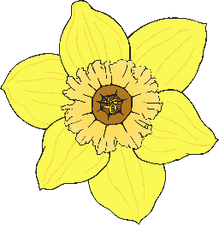

Things I can do for my mummy…

Things my mummy does for me…



Things I can do for my mummy…