**Mood Booster**

These cards are intended as a quick choice of ideas to help lift someone’s mood.

Each card has an activity that may help a child feel a little brighter if they are having a sad day.

Everyone is different and each child may respond differently to each activity.

We hope this helps!

© 2023 Little Owls Resources

Cards

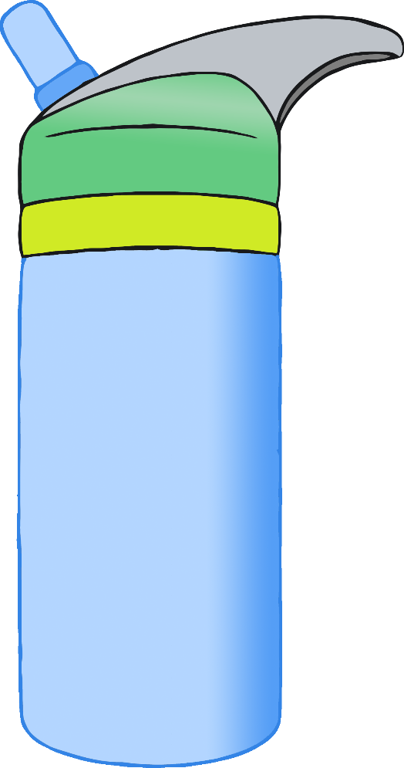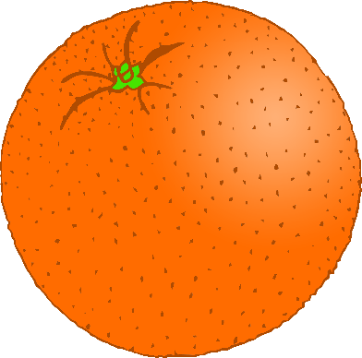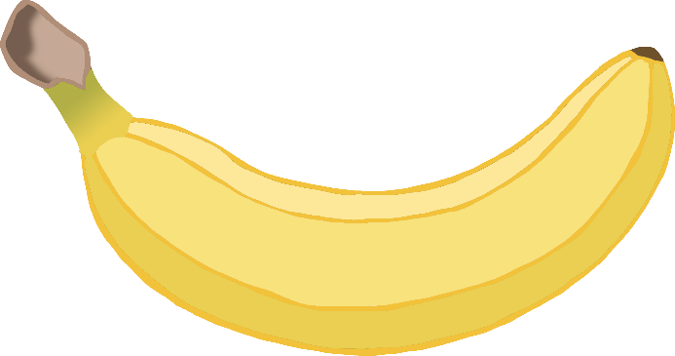

© 2023 Little Owls Resources

Eat a healthy snack!

**Mood Booster**

**1**

© 2023 Little Owls Resources

Drink some water!

**Mood Booster**

**2**

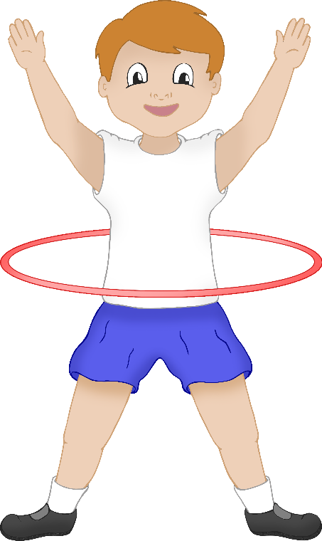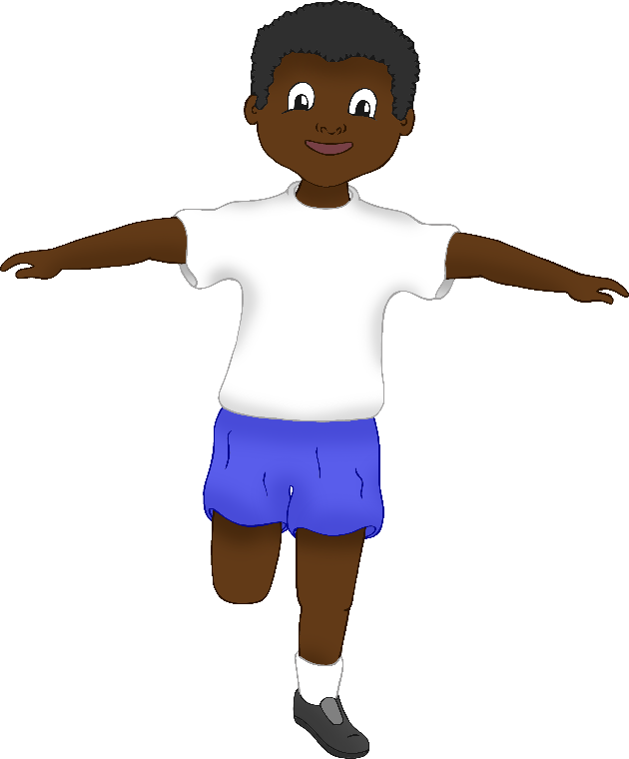

© 2023 Little Owls Resources

Go for a walk!

**Mood Booster**

**3**

© 2023 Little Owls Resources

Do some exercise!

**Mood Booster**

**4**

© 2023 Little Owls Resources

Read a book!

**Mood Booster**

**5**

© 2023 Little Owls Resources

Role-play a character!

**Mood Booster**

**6**

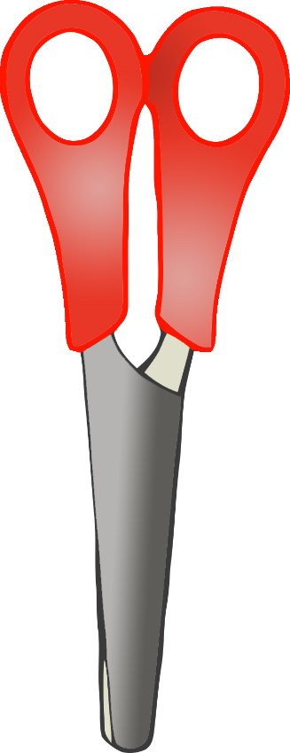

© 2023 Little Owls Resources

Paint a picture!

**Mood Booster**

**7**

© 2023 Little Owls Resources

Make a model!

**Mood Booster**

**8**

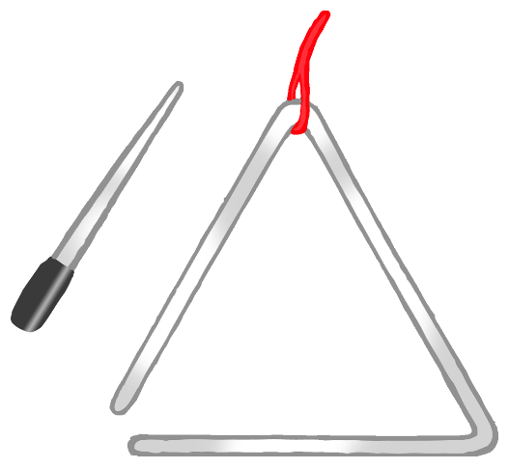

© 2023 Little Owls Resources

Sing a song or make some music!

**Mood Booster**

**9**

© 2023 Little Owls Resources

Listen to some music!

**Mood Booster**

**10**

© 2023 Little Owls Resources

Get in the sunshine!

**Mood Booster**

**11**

© 2023 Little Owls Resources

Get outdoors into nature!

**Mood Booster**

**12**

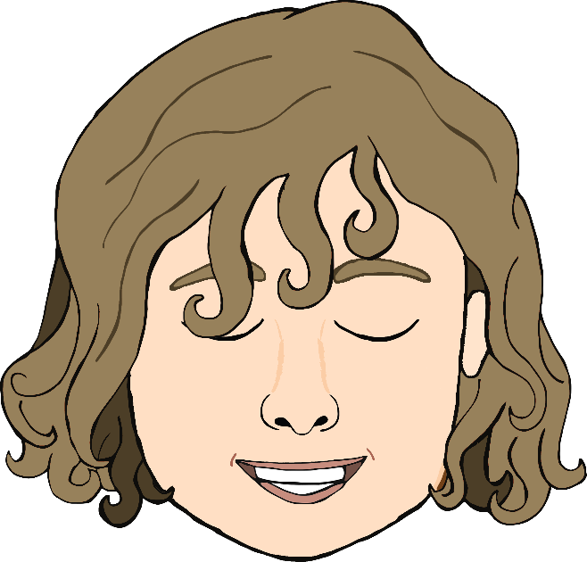

© 2023 Little Owls Resources

Have some quiet time.

**Mood Booster**

**13**

© 2023 Little Owls Resources

Do some yoga stretches.

**Mood Booster**

**14**

© 2023 Little Owls Resources

Help someone else with something.

A kind act!

**Mood Booster**

**15**

© 2023 Little Owls Resources

Think of the things you are thankful for.

**Mood Booster**

**16**

© 2023 Little Owls Resources

Talk with a friend or family member.

**Mood Booster**

**17**

© 2023 Little Owls Resources

Do something you really enjoy!

**Mood Booster**

**18**

© 2023 Little Owls Resources

**Mood Booster**

© 2023 Little Owls Resources

**Mood Booster**