dragonfly

snail

spider

worm

bee

caterpillar

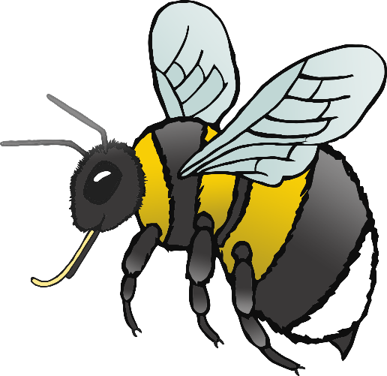

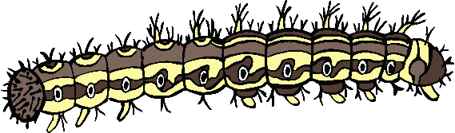

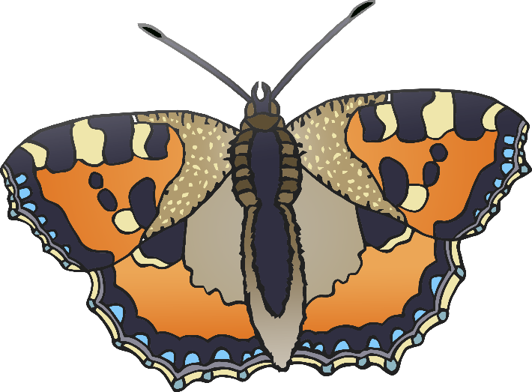

fly

butterfly

ant

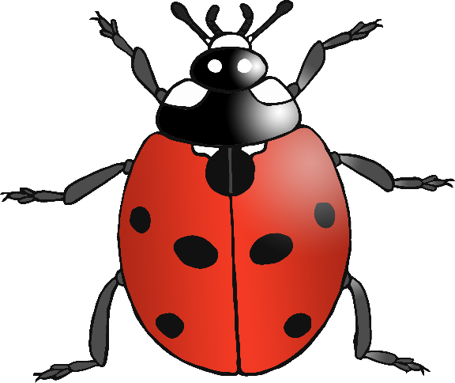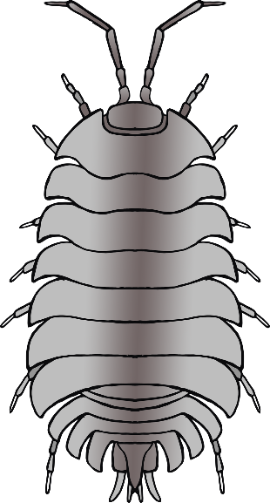

ladybird

woodlouse

centipede