10

9

8

7

6

5

4

3

2

1

1

2

3

4

5

1

2

3

4

5

6

7

8

9

10

1

2

3

4

5

1

2

3

4

5

6

7

8

9

10

1

2

3

4

5

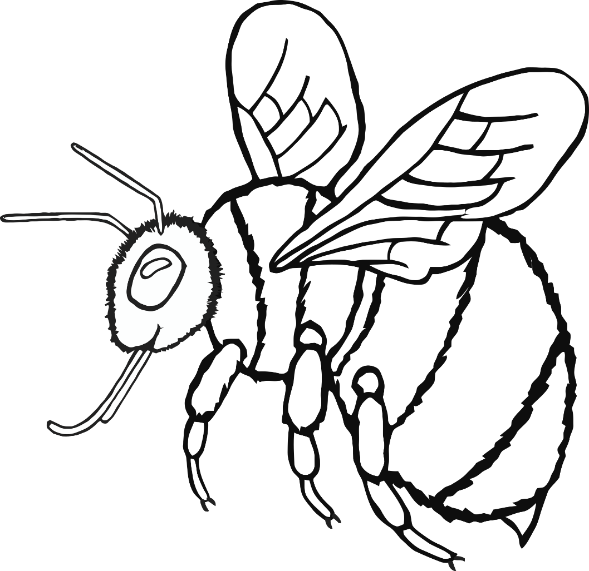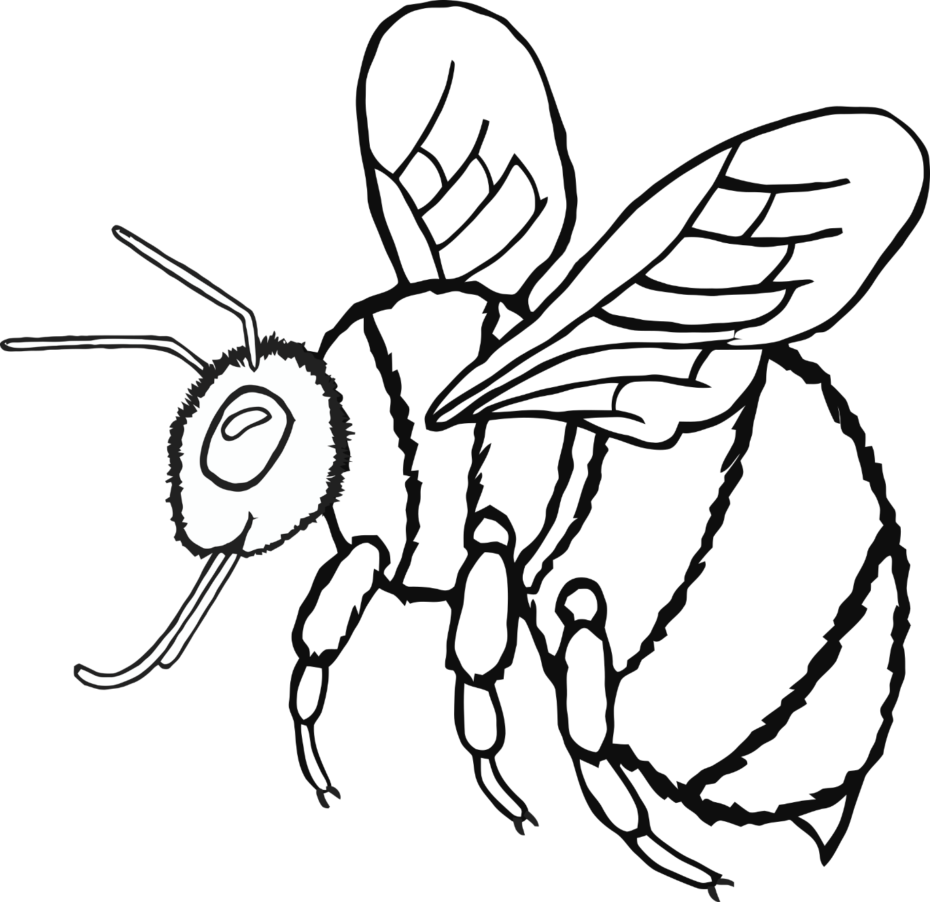

0

1

2

3

4

5

6

7

8

9

10

11

12

13

14

15

16

17

18

19

20

0

1

2

3

4

5

6

7

8

9

10

11

12

13

14

15

16

17

18

19

20

0

1

2

3

4

5

6

7

8

9

10

11

12

13

14

15

16

17

18

19

20