**Design a Woodlouse!**

© 2020 Little Owls Resources

**Design an Ant!**

© 2020 Little Owls Resources

**Design a Spider!**

© 2020 Little Owls Resources

**Design a Centipede!**

© 2020 Little Owls Resources

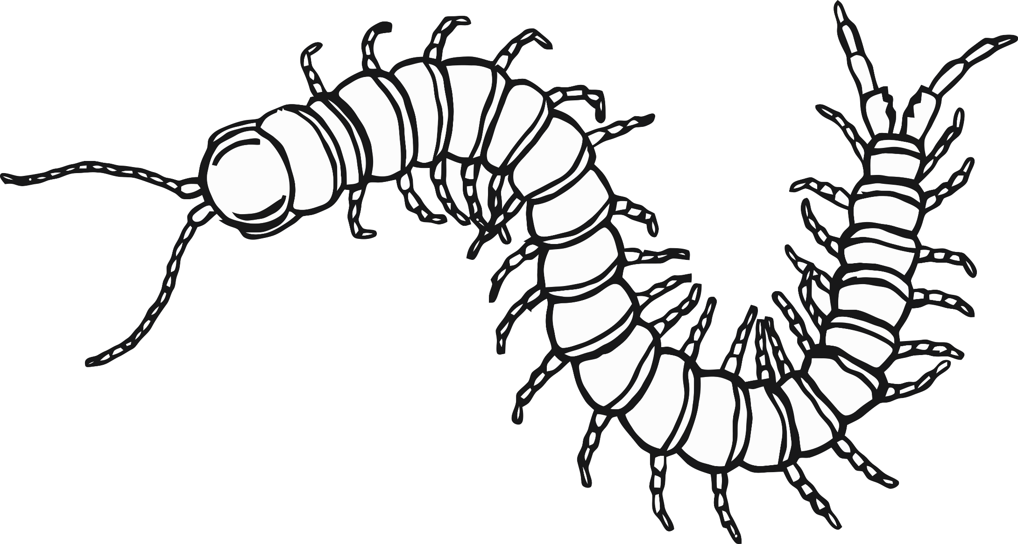

**Design a Ladybird!**

© 2020 Little Owls Resources

**Design a Butterfly!**

© 2020 Little Owls Resources

**Design a Bee!**

© 2020 Little Owls Resources