Minibeasts

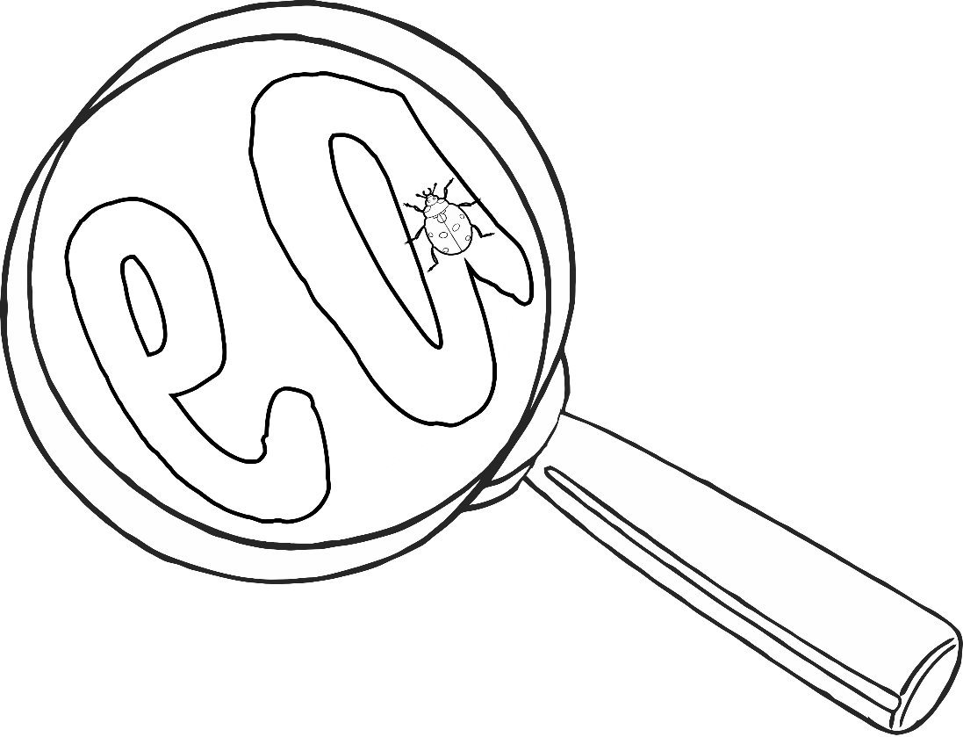

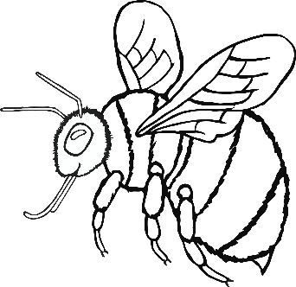

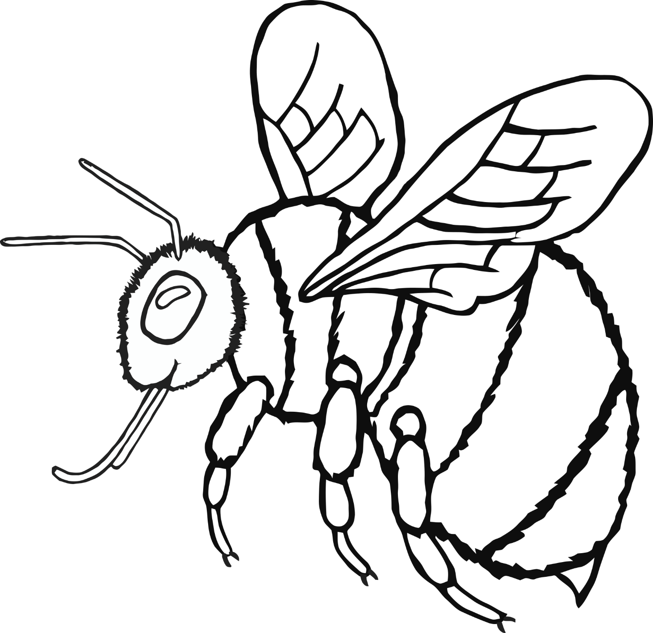

**bee**

**butterfly**

**caterpillar**

**ladybird**

**ant**

**snail**

**spider**

**fly**

**dragonfly**

**woodlouse**

**centipede**

**earwig**



