**Minibeast Activity**

**Challenge!**

**1**

Wiggle along the floor like a worm.

Wiggle! Wiggle!

**Minibeast Activity**

**Challenge!**

**2**

Crawl Crawl Crawl

like a ladybird then… fly!

**Minibeast Activity**

**Challenge!**

**3**

Keep very still until a fly comes close then… grab it!

**Minibeast Activity**

**Challenge!**

**4**

Slither so slowly like a snail…

Slither Slither

**Minibeast Activity**

**Challenge!**

**5**

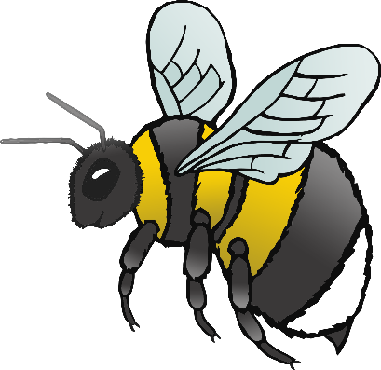

Fly around like a buzzing bee!

Buzz! Buzz!

**Minibeast Activity**

**Challenge!**

**6**

Scuttle away like a centipede!

Scuttle! Scuttle!

**Minibeast Activity**

**Challenge!**

**7**

Fly so fast like a speedy dragonfly!

**Minibeast Activity**

**Challenge!**

**8**

Fly as quietly as you can… like a butterfly!

