**Minibeast Word Mat**

© 2021 Little Owls Resources

woodlouse

centipede

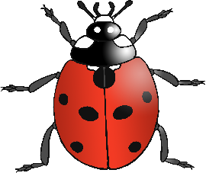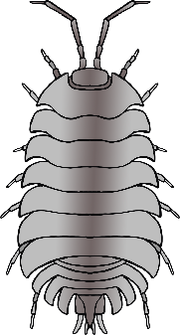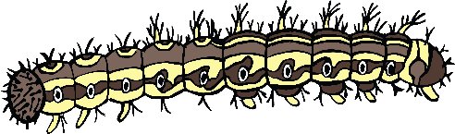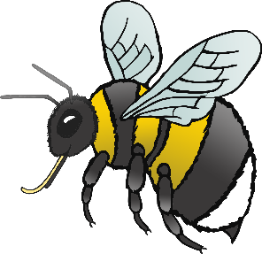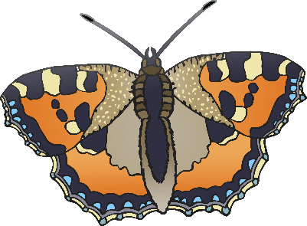

butterfly

bee

snail

worm

fly

caterpillar

ladybird

spider

dragonfly

ant