Ladybird

Ladybird

Ladybird

Ladybird

Bee

Bee

Bee

Bee

Butterfly

Butterfly

Butterfly

Butterfly

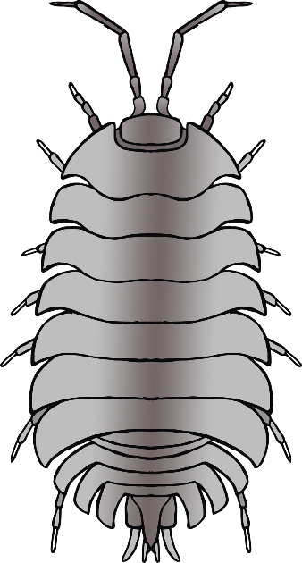

Woodlouse

Woodlouse



Woodlouse

Woodlouse

Worm

Worm

Worm

Worm

Fly

Fly

Fly

Fly

Snail

Snail

Snail

Snail

Spider

Spider

Spider

Spider

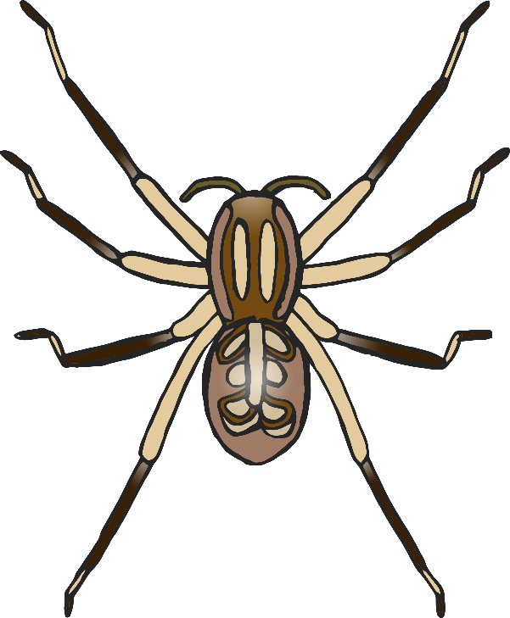

Dragonfly

Dragonfly

Dragonfly

Dragonfly

Centipede

Centipede

Centipede

Centipede