Activity

Science

Minibeast

Hunt

p2: Activity Card (detailed breakdown of the activity, vocabulary, questions, etc.)

p3: ‘Family Fun’ Activity Cards (shorthand version of the activity to send home)

p4: ‘Minibeast Hunt’ poster (for use with our Science ‘Activity Space’ Banners)

p5: Minibeast checklist

p6: ‘Draw minibeasts’ sheet

p7-9: Bumblebee body parts sheets x3

p10: Minibeast word mat

p11-15: Minibeast word cards (for display or as flash cards)

p16-18: ‘What did we do?’ sheets (for writing, drawing, or adding a photograph)

p19-21: ‘What did we find out?’ sheets (for writing, drawing, or adding a photograph)

This pack includes…

© 2022 Little Owls Resources

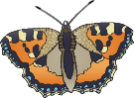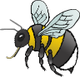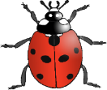

Minibeast

Hunt

Science

Activity

(Understanding the World)

Extra Challenge!

Go out and search for minibeasts! You could explore in an outdoor area/garden, park, forest or on the way to and from places.

Our checklists may help you to name, classify and describe the minibeasts that you find, along with our word cards and mats.

You may like to record what you have found by taking photos (to inspire further talk in settings or at home later) or encourage children to make marks/do drawings to capture what they have seen and found out.

The bravest among you may like to model careful handling of appropriate minibeasts and show the importance of placing them back where they were found.

With younger children focus on the excitement of exploring the outdoors and key vocabulary (using pointing and actions), such as to teach the names of a few minibeasts, key objects and actions... ‘Ladybird’… ‘Ladybird on a leaf’… ‘Butterfly’… ‘Butterfly flying’… ‘Where is the worm?’…’There it is!’

Moving like minibeasts is fun for all ages, (e.g. ‘wriggle like a worm’) and could be used as an activity to interject at any point.

Counting may naturally occur, e.g. ‘How many snails are there?’ ‘One, two, three. Three snails!’

Imagine you are a minibeast. Which minibeast would you like to be? How do you feel? Would you like to be able to fly? Would you be scared looking up at huge humans?

Where is …the snail? What is it? What have you found? Where does it live? What might we find under this log? Does it have…any wings/legs? How many legs does it have? Shall we try to count them? How does it move? Do you think…it can fly? Why? What makes you think that?

Key Questions:

(Progressing in difficulty)

Key Vocabulary:

(Progressing in difficulty)

Further resources within this pack. Plus, more ‘Minibeast’ resources at

<https://littleowls-premium.com/minibeasts>

Additional Resources:

Minibeast names (see word cards), *look, find*

Body parts: *legs, wings, body, shell, antennae*

Movements: *crawl, fly, jump, hop, zoom, wriggle, flutter, slither, slide, creep, spin, curl up, swoop, march, scuttle*

*Insect* (main features = 6 jointed legs, 2 antennae, 3 body sections and often wings)

**Birth to 3** - Explore and respond to different natural phenomena in their setting and on trips.

**3 and 4 -** Talk about what they see using a wide vocabulary. - Begin to understand the need to respect and care for the natural environment and all living things.

**Reception -** Explore the natural world around them. – Describe what they see, hear and feel whilst outside. **ELG –** Explore the natural world around them, making observations and drawing pictures of animals and plants.

Development Matters:

© 2022 Little Owls Resources

Activity Description:

Outdoor space – garden/park/forest

*Optional* – magnifying glasses, checklists, activity sheets/paper for drawing/mark making, clipboards

You will need:

Family Fun!

Go out and search for minibeasts! You could explore in a garden, park, forest or on the way to and from places.

Describe what you find, e.g. names of minibeasts (snail, ladybird, worm), body parts (legs, wings, shell) and how they move (crawl, slither, fly).

We’d love to see some photos or drawings of what you found!

Minibeast

Hunt

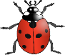

© 2022 Little Owls Resources

Family Fun!

Go out and search for minibeasts! You could explore in a garden, park, forest or on the way to and from places.

Describe what you find, e.g. names of minibeasts (snail, ladybird, worm), body parts (legs, wings, shell) and how they move (crawl, slither, fly).

We’d love to see some photos or drawings of what you found!

Minibeast

Hunt



© 2022 Little Owls Resources

Family Fun!

Go out and search for minibeasts! You could explore in a garden, park, forest or on the way to and from places.

Describe what you find, e.g. names of minibeasts (snail, ladybird, worm), body parts (legs, wings, shell) and how they move (crawl, slither, fly).

We’d love to see some photos or drawings of what you found!

Minibeast

Hunt



© 2022 Little Owls Resources

Family Fun!

Go out and search for minibeasts! You could explore in a garden, park, forest or on the way to and from places.

Describe what you find, e.g. names of minibeasts (snail, ladybird, worm), body parts (legs, wings, shell) and how they move (crawl, slither, fly).

We’d love to see some photos or drawings of what you found!

Minibeast

Hunt



© 2022 Little Owls Resources

ttt

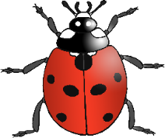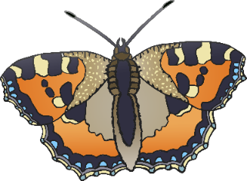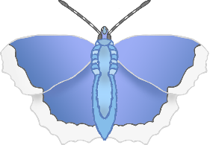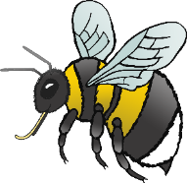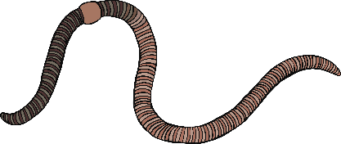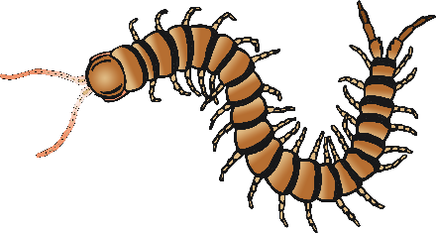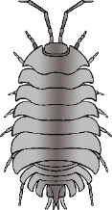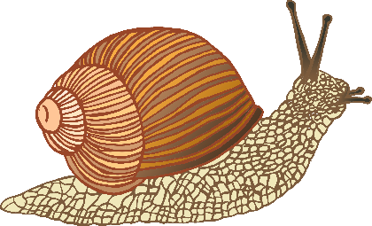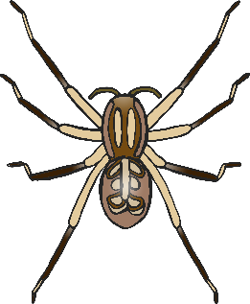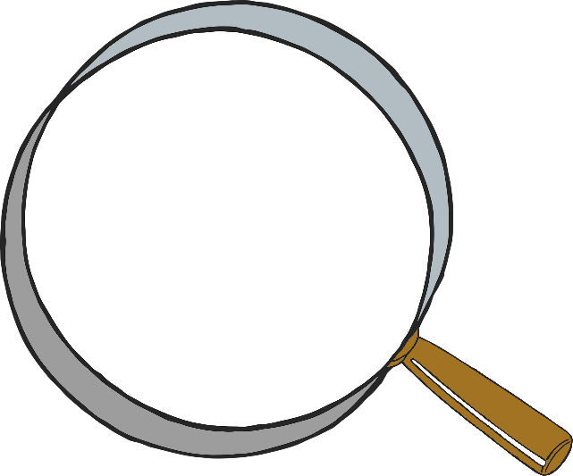

Minibeast Hunt

© 2022 Little Owls Resources

*\*For use with the ‘Science Banner’ display.*

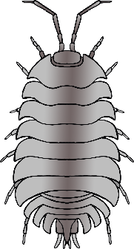

Minibeast Checklist

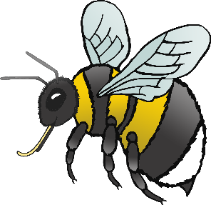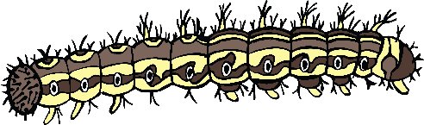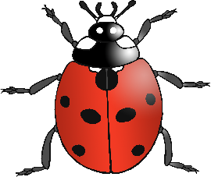

earwig

ant

worm

bee

caterpillar

ladybird

dragonfly

snail

butterfly

centipede

woodlouse

spider

fly

© 2022 Little Owls Resources

Name:

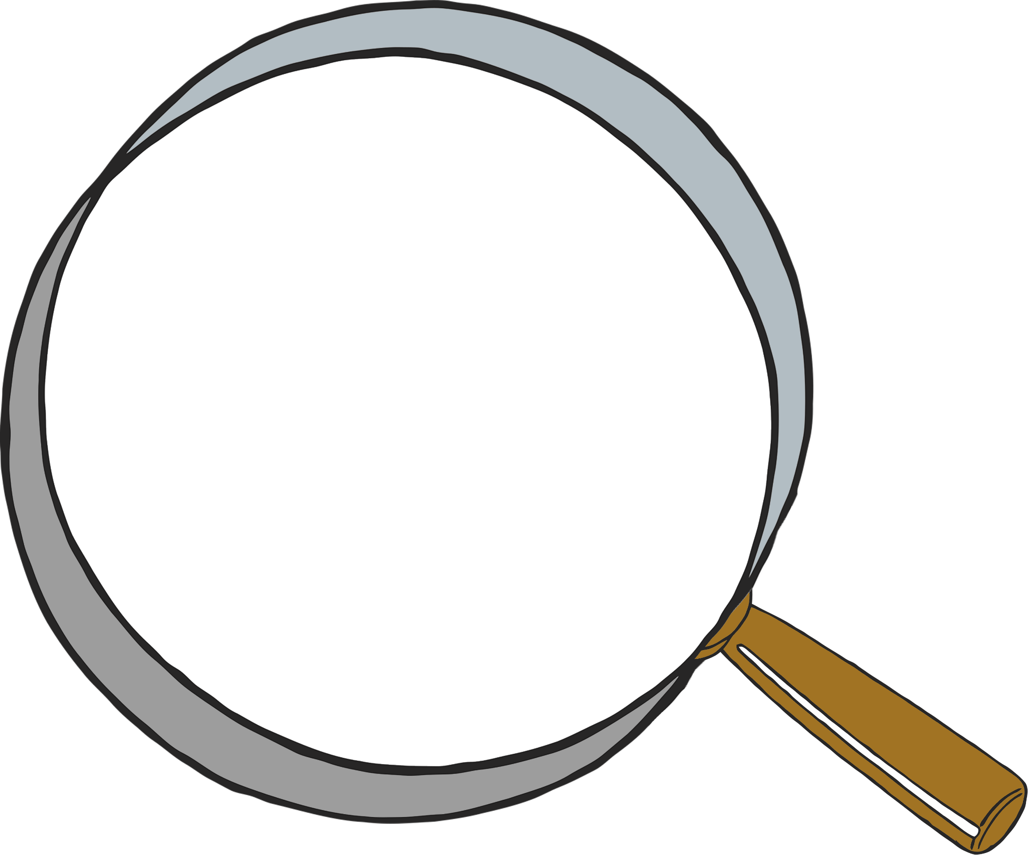

© 2022 Little Owls Resources

Draw what you find!

What minibeasts can you see?

**Bumblebee body parts**

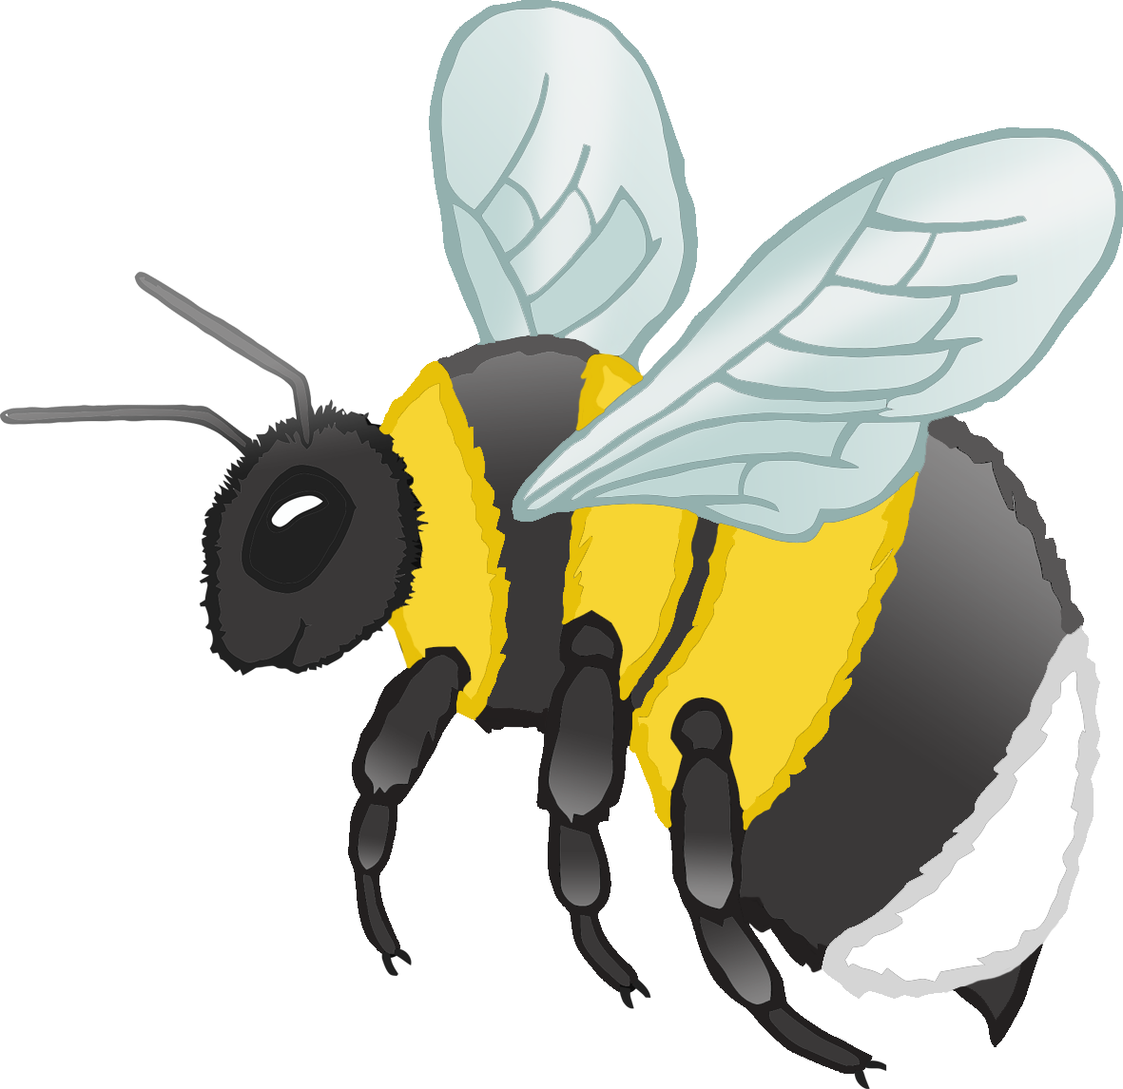

© 2022 Little Owls Resources

antenna

**w**ing

stinger

leg

eye

a

**w**

s

l

e

**Bumblebee body parts**



© 2022 Little Owls Resources

**Bumblebee body parts**



© 2022 Little Owls Resources

Minibeast Word Mat

© 2022 Little Owls Resources

centipede

woodlouse

ant

dragonfly



bee

worm

snail

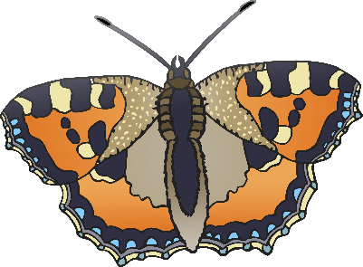

butterfly

spider



ladybird

caterpillar

fly

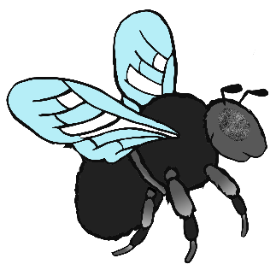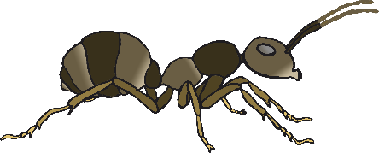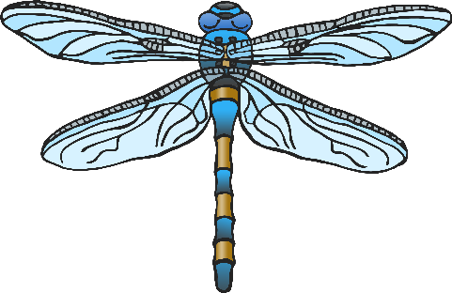

earwig

dragonfly

snail

© 2022 Little Owls Resources

© 2022 Little Owls Resources

© 2022 Little Owls Resources

spider

worm

bee

caterpillar

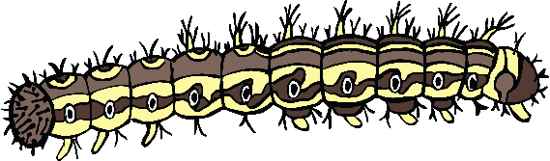

© 2022 Little Owls Resources

© 2022 Little Owls Resources

© 2022 Little Owls Resources

fly

butterfly

ant

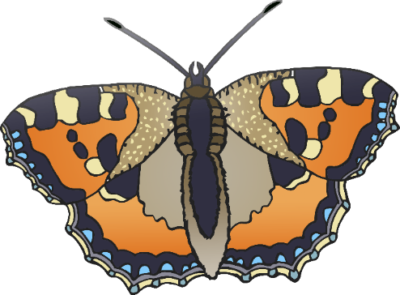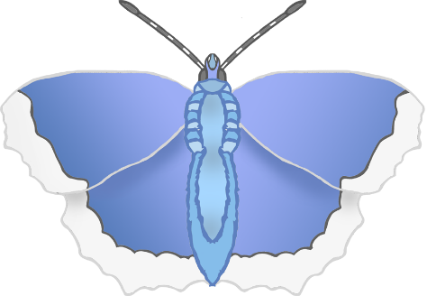

© 2022 Little Owls Resources

© 2022 Little Owls Resources

© 2022 Little Owls Resources

ladybird

woodlouse

centipede

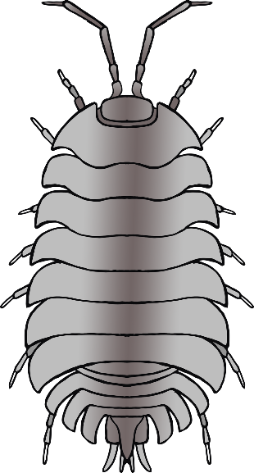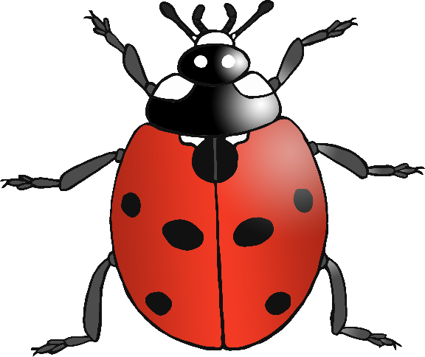

© 2022 Little Owls Resources

© 2022 Little Owls Resources

© 2022 Little Owls Resources

earwig

magnifying glass

minibeasts

© 2022 Little Owls Resources

© 2022 Little Owls Resources

© 2022 Little Owls Resources

What did we do?

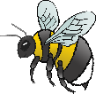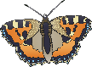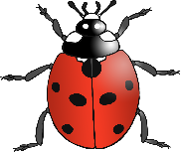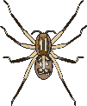

__________________________________________________________________

© 2022 Little Owls Resources

What did we do?



____________________________

© 2022 Little Owls Resources

What did we do?



© 2022 Little Owls Resources

__________________________________________________________________

What did we find out?

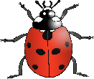

© 2022 Little Owls Resources

What did we find out?



____________________________

© 2022 Little Owls Resources

What did we find out?



© 2022 Little Owls Resources