These cards can be used as they are with pencil/crayons or laminated for use with playdough or whiteboard pens.

Minibeast Doubling

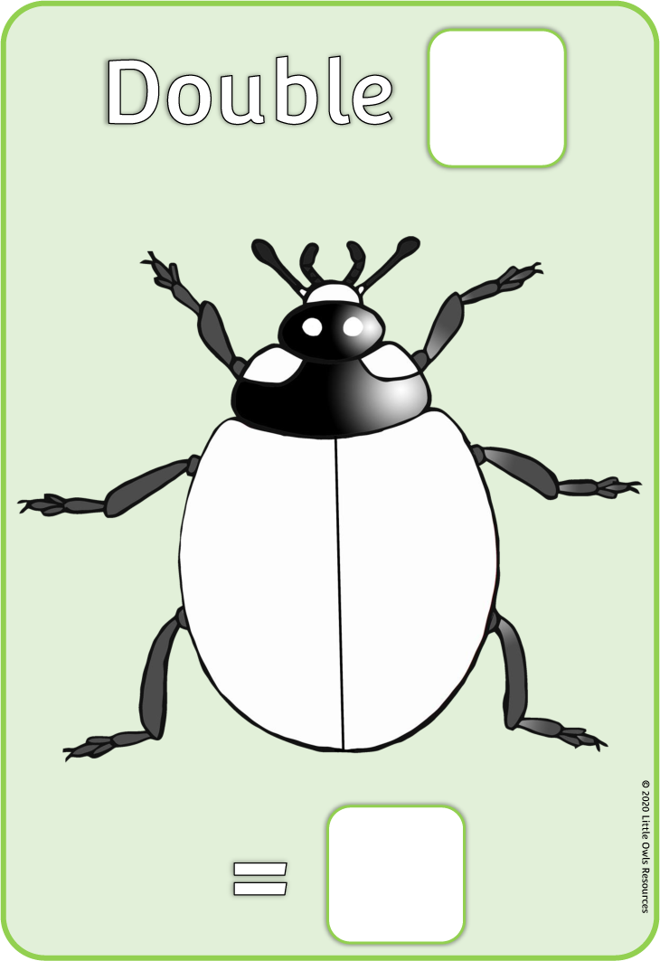

3



6

In the example below, the adult has written an appropriate double for the child to investigate in the top box.

Then the child has used blue playdough to put three dots on either side of the ladybird outline.

Finally, the child has written the answer in at the bottom of the card.

**Double**

**=**

© 2020 Little Owls Resources

© 2020 Little Owls Resources

**=**

**Double**