**Count the minibeasts**

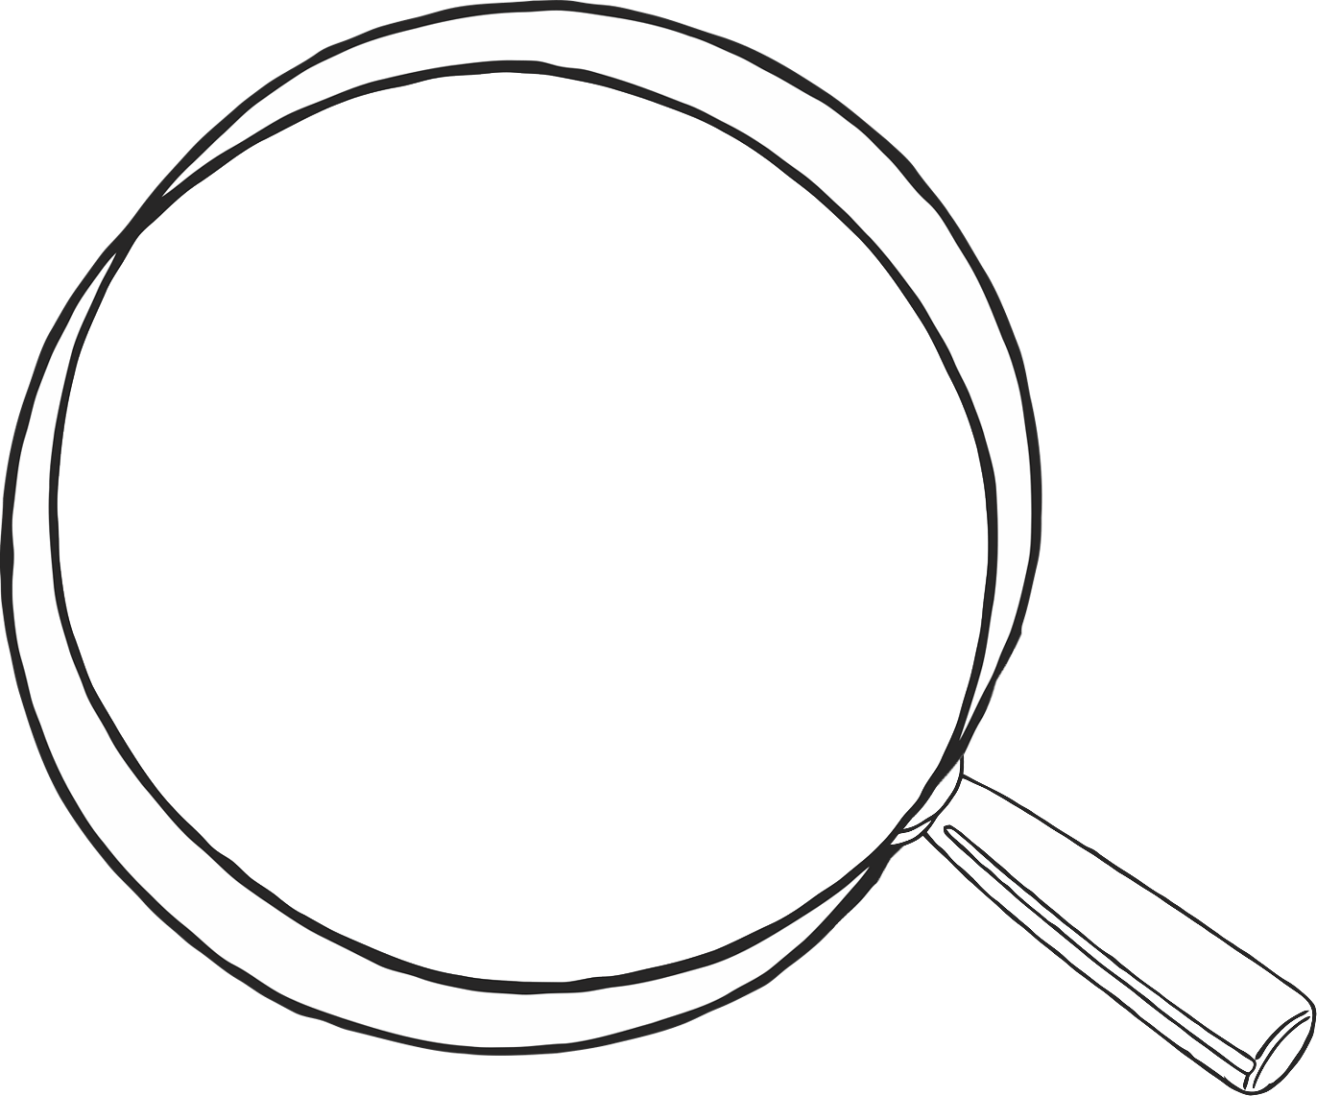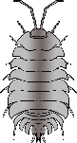

**1**

© 2020 Little Owls Resources

**Count the minibeasts**

**2**

© 2020 Little Owls Resources

**Count the minibeasts**

**3**

© 2020 Little Owls Resources

**Count the minibeasts**

**4**

© 2020 Little Owls Resources

**Count the minibeasts**

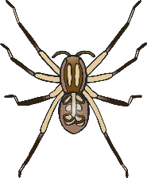

**5**

© 2020 Little Owls Resources

**Count the minibeasts**

**6**

© 2020 Little Owls Resources

**Count the minibeasts**

**7**

© 2020 Little Owls Resources

**Count the minibeasts**

**8**

© 2020 Little Owls Resources

**Count the minibeasts**

**9**

© 2020 Little Owls Resources

**10**

© 2020 Little Owls Resources

**Count the minibeasts**