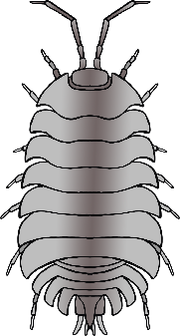

ant

woodlouse

centipede

**Minibeast Checklist**

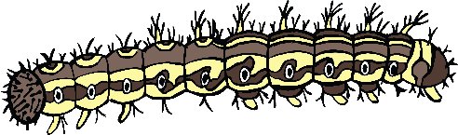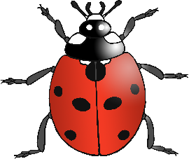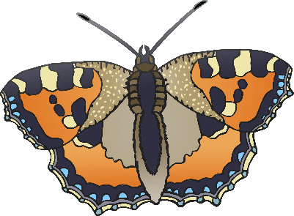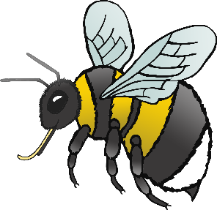

© 2020 Little Owls Resources

snail

worm

caterpillar

ladybird

fly

spider

butterfly

bee

dragonfly