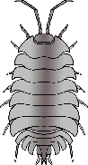

www.littleowls-premium.com

© 2019 Little Owls Resources

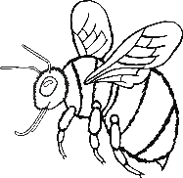

www.littleowls-premium.com

© 2019 Little Owls Resources