Mindfulness fish colouring

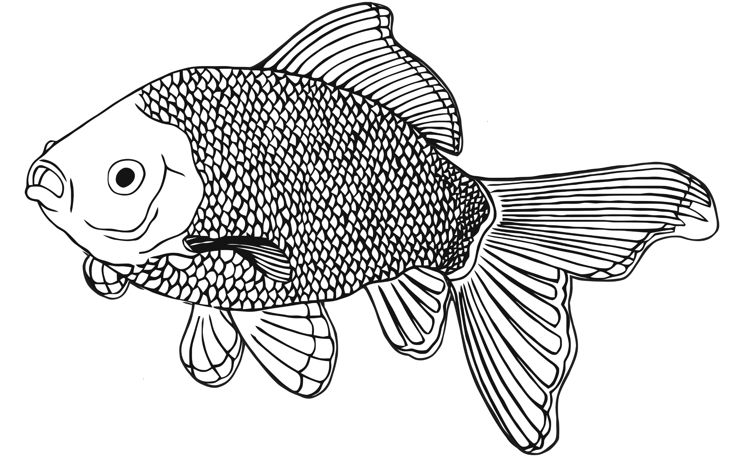

© 2022 Little Owls Resources