**Mermaid Talk**

© 2023 Little Owls Resources

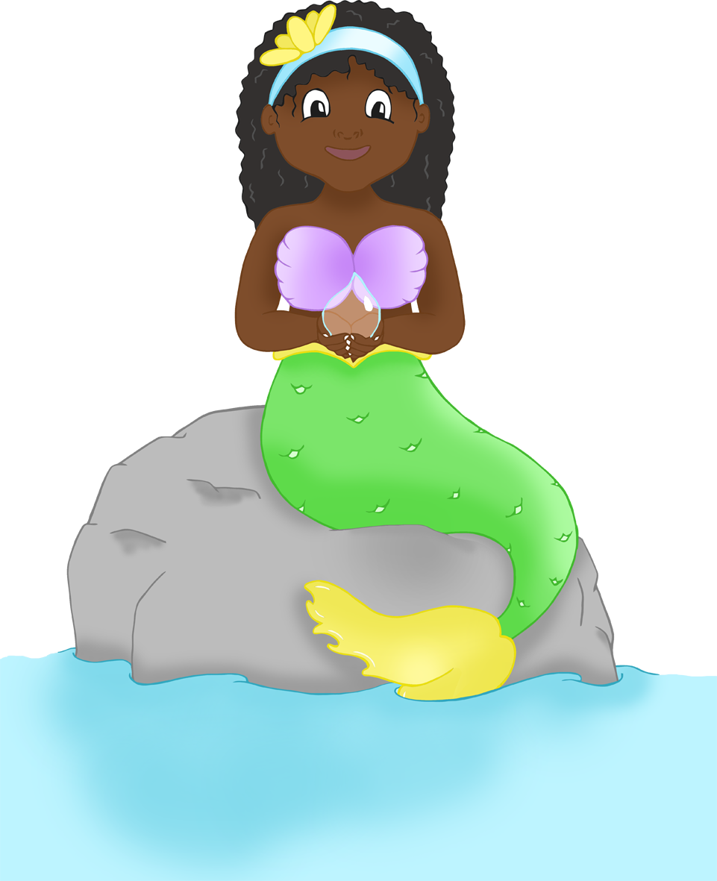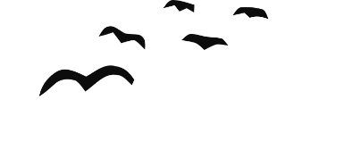

**Mermaid Talk**

© 2023 Little Owls Resources

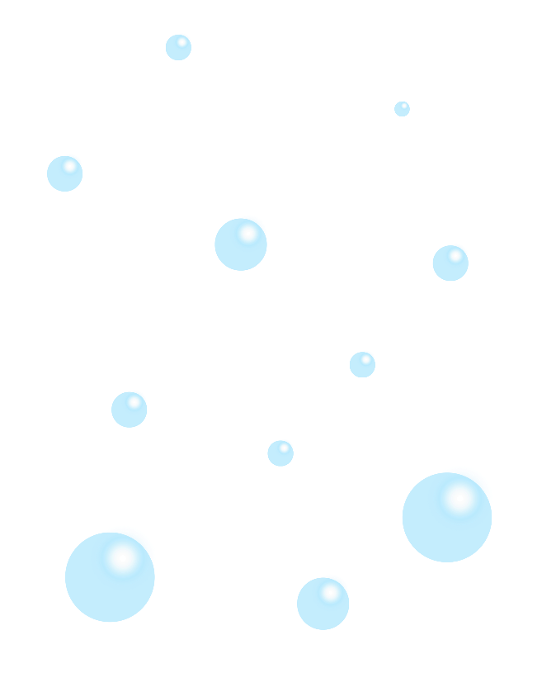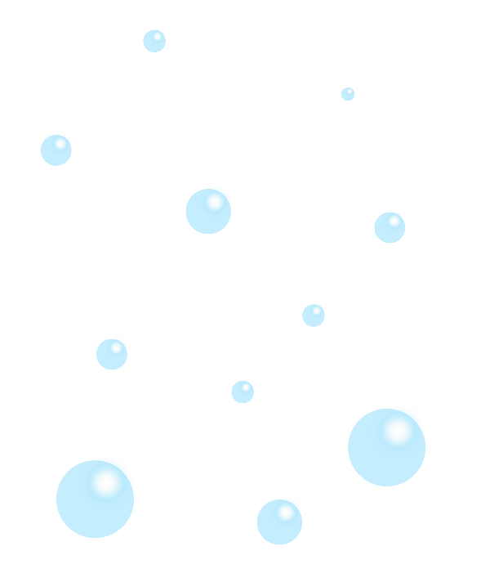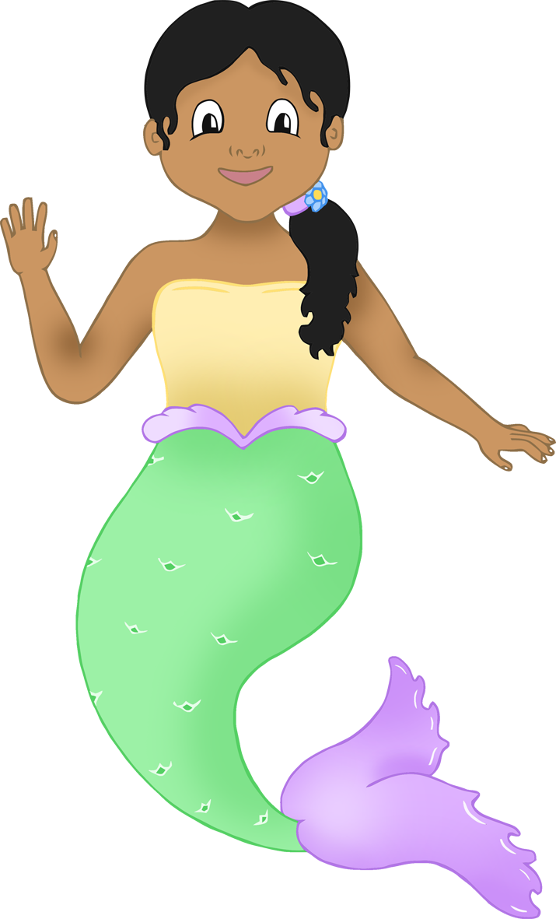

**Mermaid Talk**

© 2023 Little Owls Resources

© 2023 Little Owls Resources

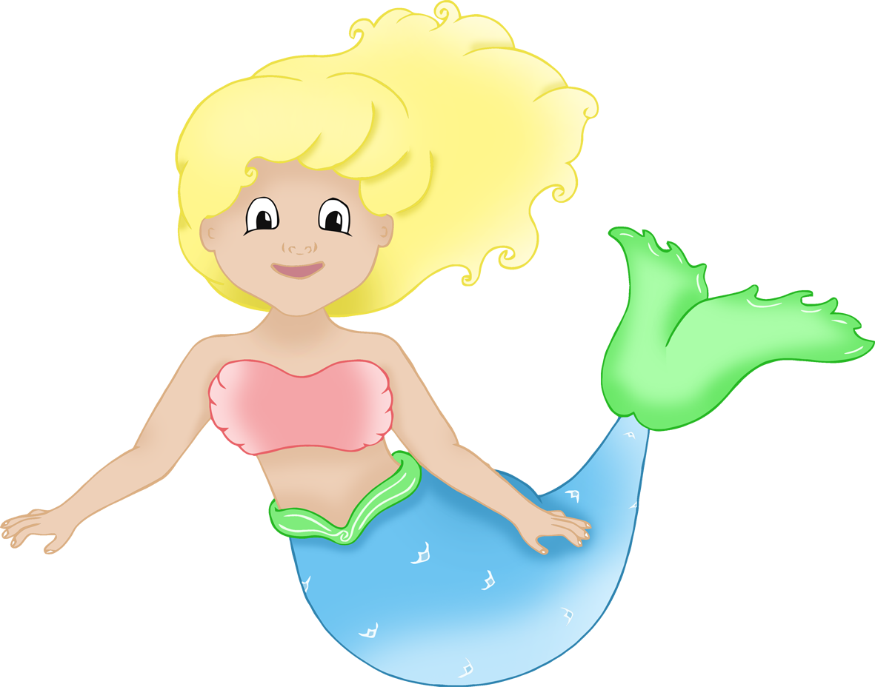

**Mermaid Talk**

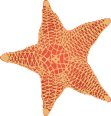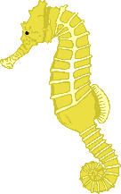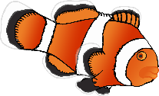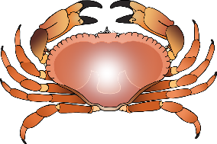

© 2023 Little Owls Resources

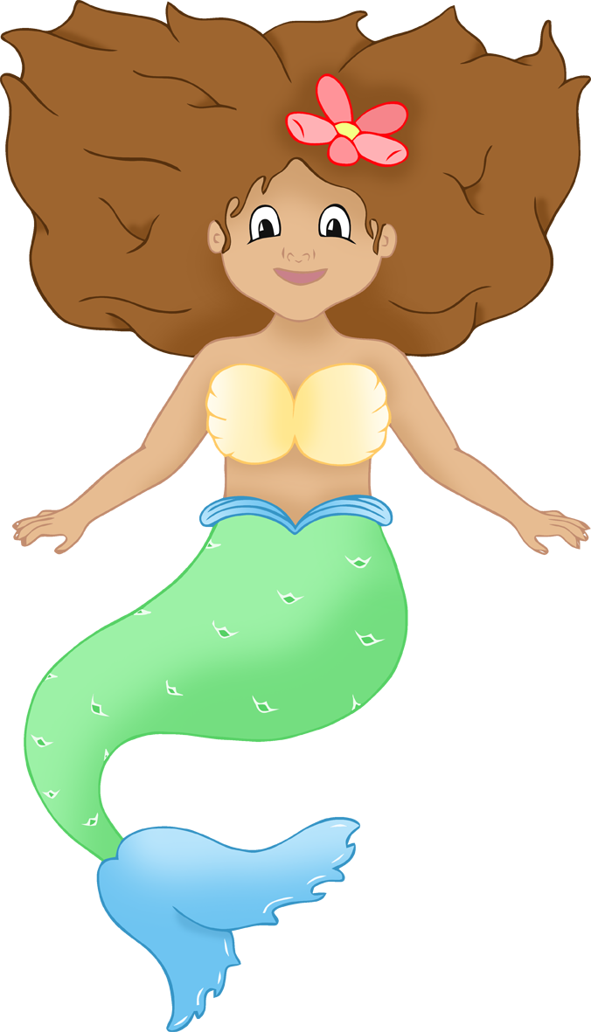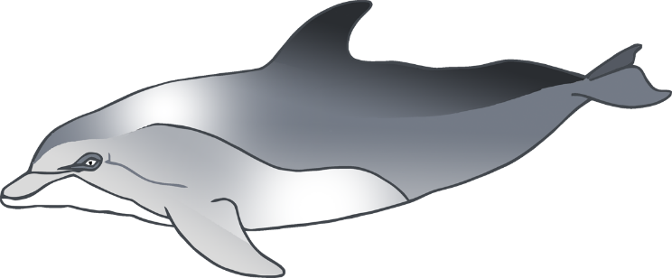

**Mermaid Talk**



© 2023 Little Owls Resources

**Merman Talk**

**Merman Talk**

© 2023 Little Owls Resources

**Merman Talk**

© 2023 Little Owls Resources

**Merman Talk**

© 2023 Little Owls Resources