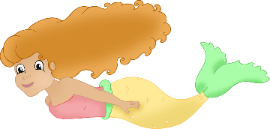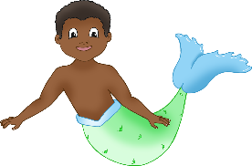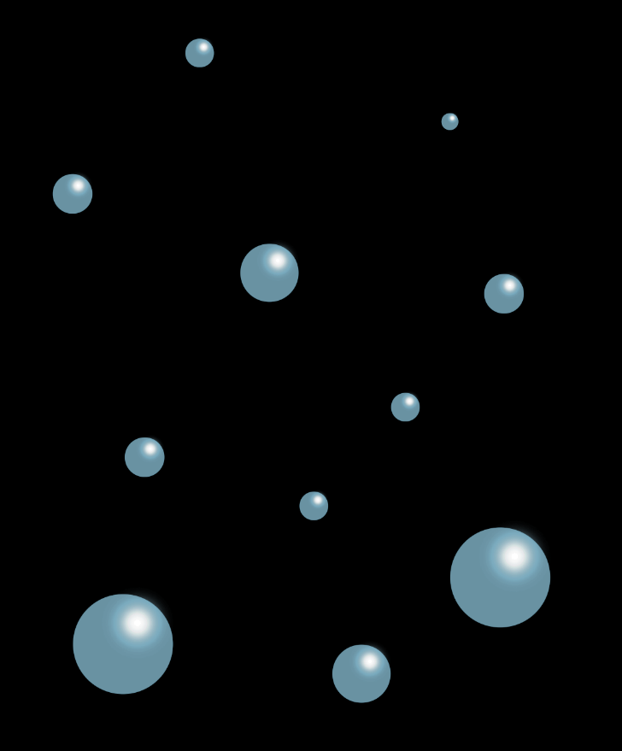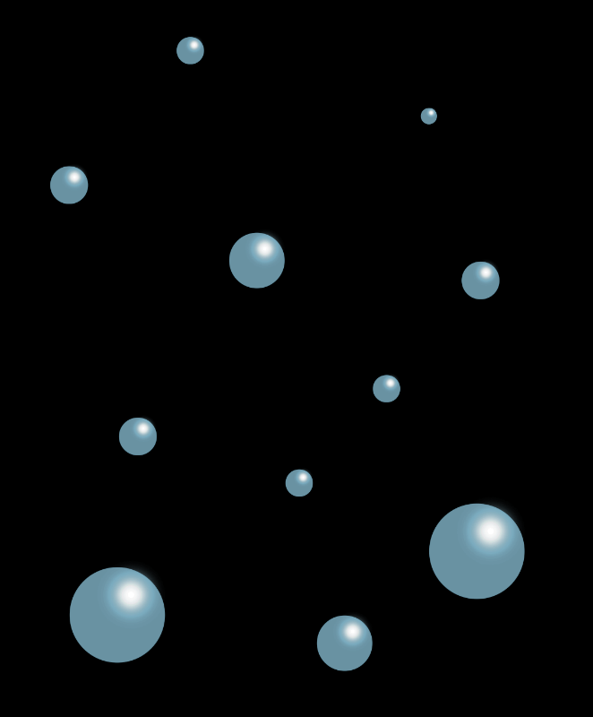

**Mermaids and Mermen**

© 2023 Little Owls Resources



© 2023 Little Owls Resources

________­­­­­­­­­­­­­­­­­­­______________________

______________________________

______________________________

______________________________

­______________________________

______________________________

­______________________________

______________________________



**Mermaids and Mermen**



© 2023 Little Owls Resources

**________­­­­­­­­­­­­­­­­­­­______________________**

**______________________________**

**______________________________**

**______________________________**

**­______________________________**

**______________________________**

**­______________________________**



**Mermaids and Mermen**



© 2023 Little Owls Resources

**Mermaids and Mermen**

**________________________________________________________________________________________________________________________________________________________________________________________________________________________________________________________________________________________________________________________________________________________________________________**