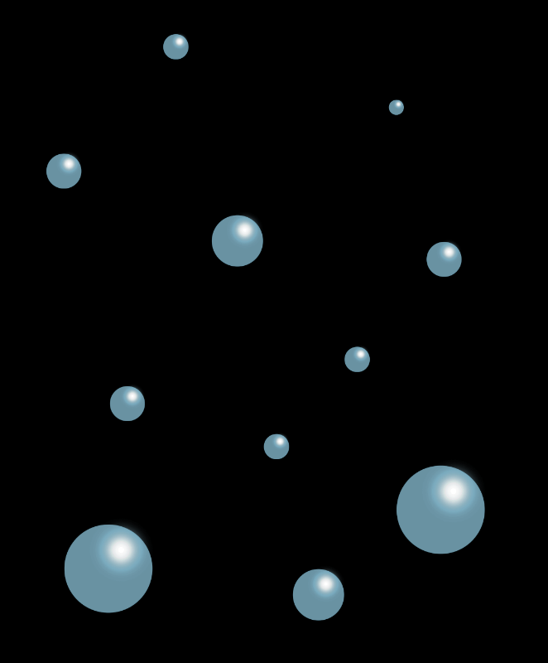

© 2023 Little Owls Resources

Name:

Age:

What do they like to eat?

What do they like to drink?

What do they do for fun?

Special ability:

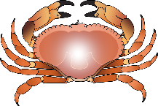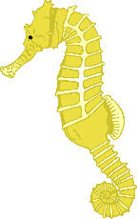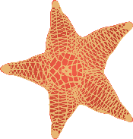

**Mermaid Character Sheet**



© 2023 Little Owls Resources

Name:

Age:

What do they like to eat?

What do they like to drink?

What do they do for fun?

Special ability:



**Mermaid Character Sheet**



© 2023 Little Owls Resources

Name:

Age:

What do they like to eat?

What do they like to drink?

What do they do for fun?

Special ability:



**Mermaid Character Sheet**



© 2023 Little Owls Resources

Name:

Age:

What do they like to eat?

What do they like to drink?

What do they do for fun?

Special ability:



**Mermaid Character Sheet**



© 2023 Little Owls Resources

Name:

Age:

What do they like to eat?

What do they like to drink?

What do they do for fun?

Special ability:



**Mermaid Character Sheet**



© 2023 Little Owls Resources

Name:

Age:

What do they like to eat?

What do they like to drink?

What do they do for fun?

Special ability:



**Mermaid Character Sheet**



© 2023 Little Owls Resources

Name:

Age:

What do they like to eat?

What do they like to drink?

What do they do for fun?

Special ability:



**Merman Character Sheet**



© 2023 Little Owls Resources

Name:

Age:

What do they like to eat?

What do they like to drink?

What do they do for fun?

Special ability:



**Merman Character Sheet**



© 2023 Little Owls Resources

Name:

Age:

What do they like to eat?

What do they like to drink?

What do they do for fun?

Special ability:



**Merman Character Sheet**



© 2023 Little Owls Resources

Name:

Age:

What do they like to eat?

What do they like to drink?

What do they do for fun?

Special ability:



**Merman Character Sheet**



© 2023 Little Owls Resources

Name:

Age:

What do they like to eat?

What do they like to drink?

What do they do for fun?

Special ability:



**Merman Character Sheet**