Mermaid name:

What do they do for fun?

© 2023 Little Owls Resources

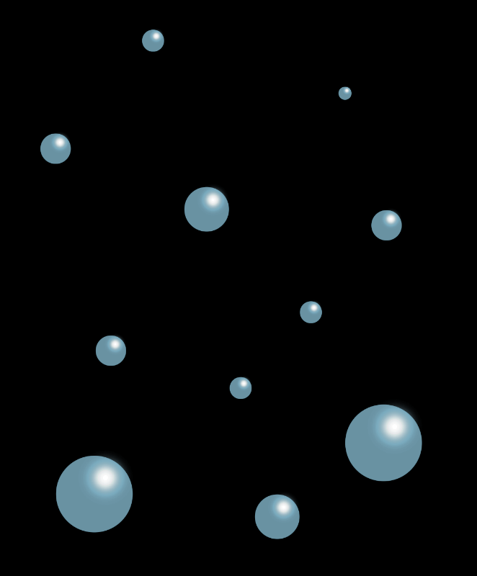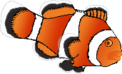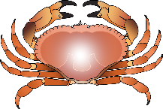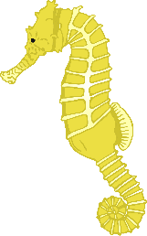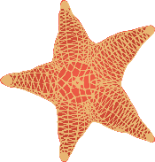

**Mermaid Character Sheet**

Mermaid name:

What do they do for fun?

© 2023 Little Owls Resources



**Mermaid Character Sheet**

Mermaid name:

What do they do for fun?

© 2023 Little Owls Resources



**Mermaid Character Sheet**

Mermaid name:

What do they do for fun?

© 2023 Little Owls Resources



**Mermaid Character Sheet**

Mermaid name:

What do they do for fun?

© 2023 Little Owls Resources



**Mermaid Character Sheet**

Mermaid name:

What do they do for fun?

© 2023 Little Owls Resources



**Mermaid Character Sheet**

Merman name:

What do they do for fun?

© 2023 Little Owls Resources



**Merman Character Sheet**

Merman name:

What do they do for fun?

© 2023 Little Owls Resources



**Merman Character Sheet**

Merman name:

What do they do for fun?

© 2023 Little Owls Resources



**Merman Character Sheet**

Merman name:

What do they do for fun?

© 2023 Little Owls Resources



**Merman Character Sheet**

Merman name:

What do they do for fun?

© 2023 Little Owls Resources



**Merman Character Sheet**