© 2021 Little Owls Resources

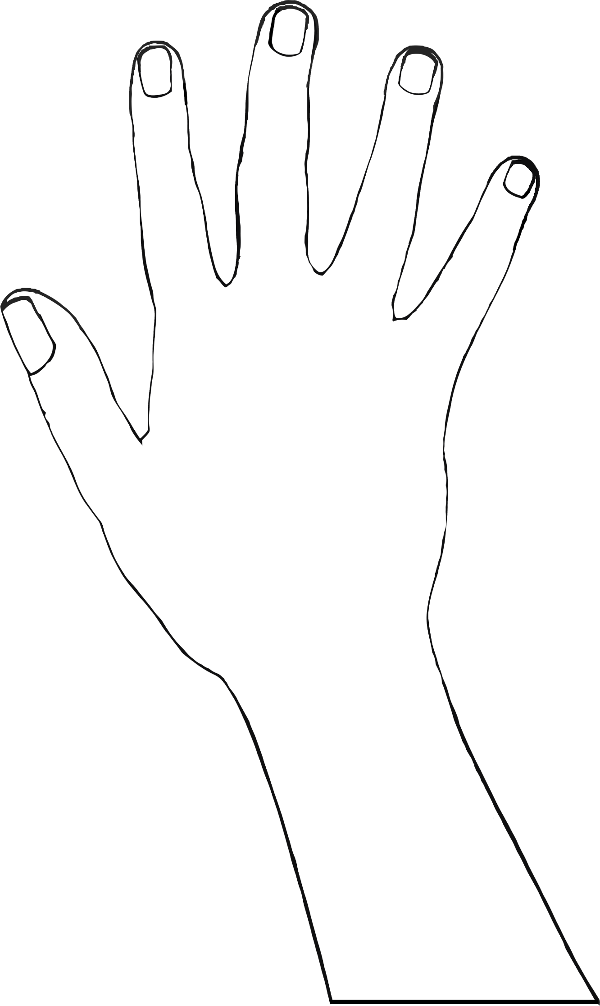

Mehndi

© 2021 Little Owls Resources



Mehndi

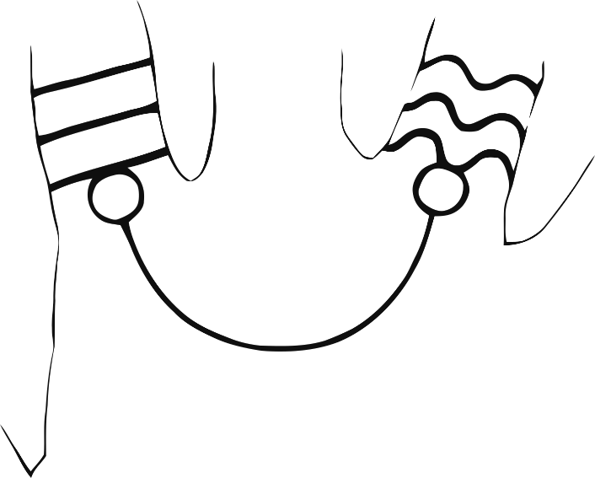

© 2021 Little Owls Resources



Mehndi

© 2021 Little Owls Resources



Mehndi

© 2021 Little Owls Resources



Mehndi