syringe

stethoscope

medicine

© 2021 Little Owls Resources

© 2021 Little Owls Resources

© 2021 Little Owls Resources

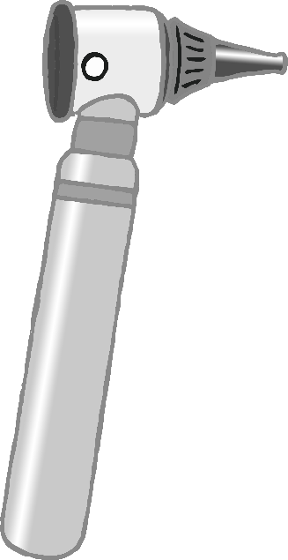

plasters

otoscope

thermometer

© 2021 Little Owls Resources

© 2021 Little Owls Resources

© 2021 Little Owls Resources

medical gloves

fob watch

doctor’s bag

© 2021 Little Owls Resources

© 2021 Little Owls Resources

© 2021 Little Owls Resources



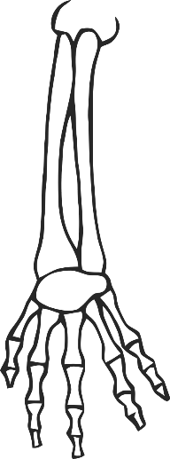

bandage

x-ray

clipboard

© 2021 Little Owls Resources

© 2021 Little Owls Resources

© 2021 Little Owls Resources